RAG Pipeline
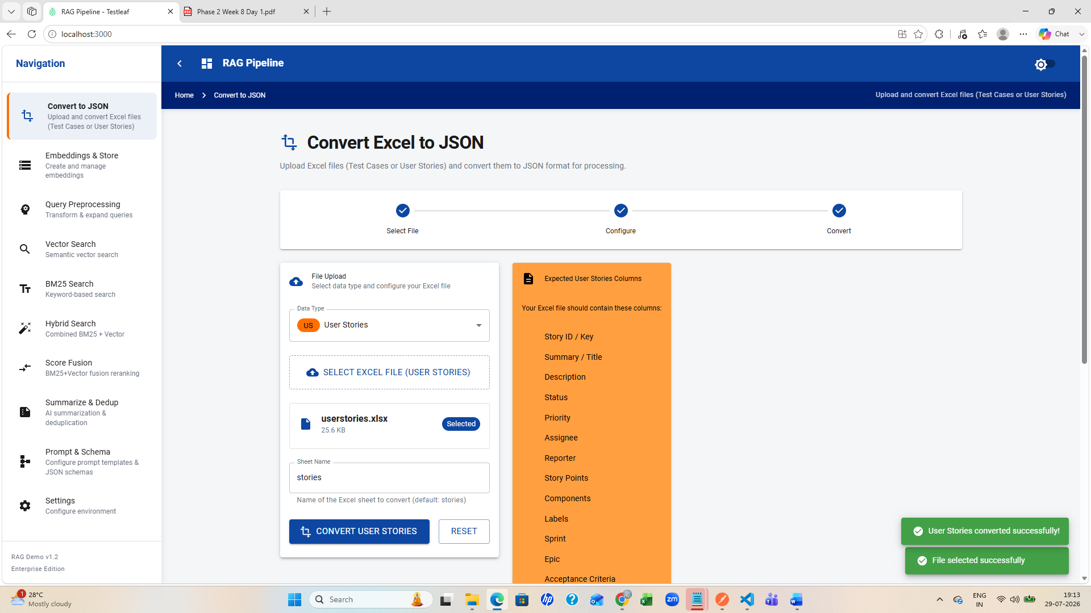
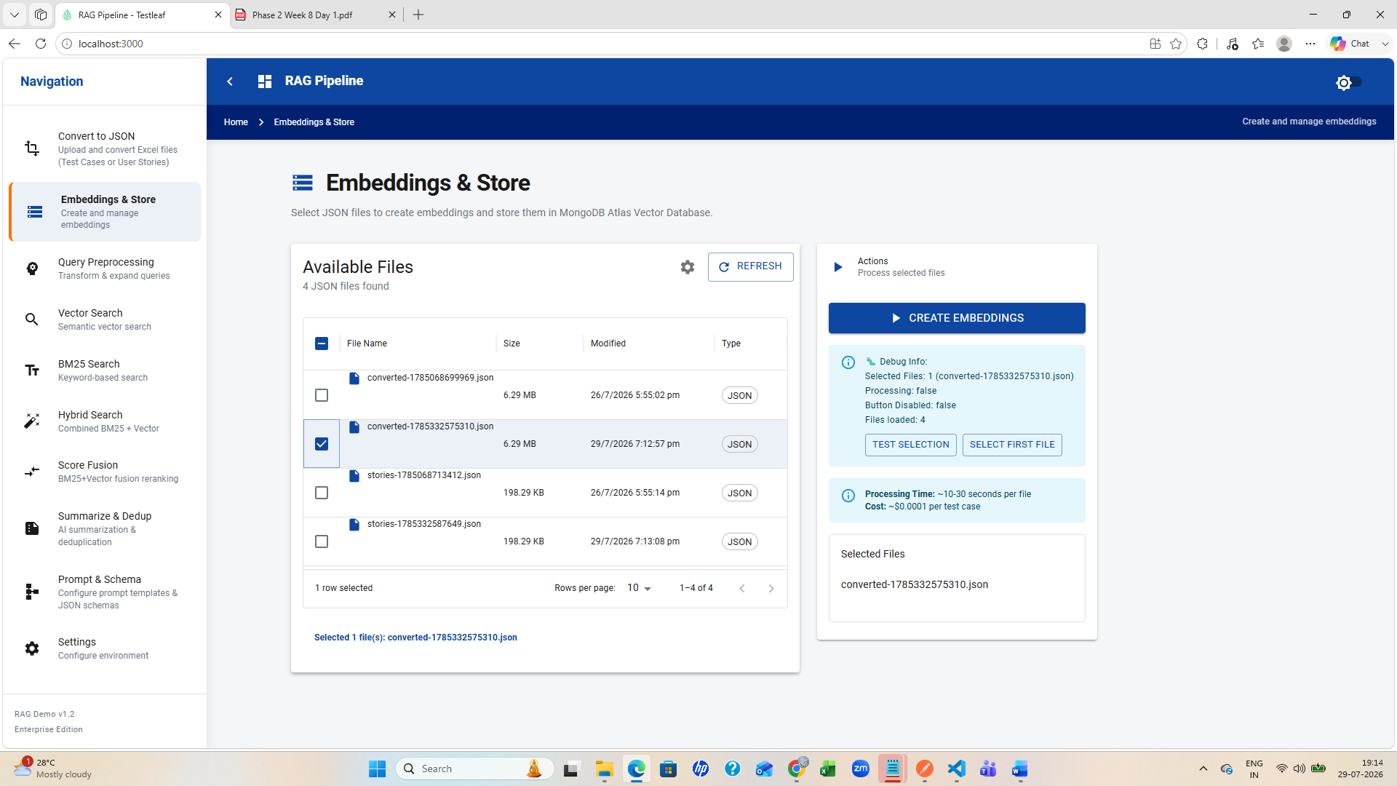
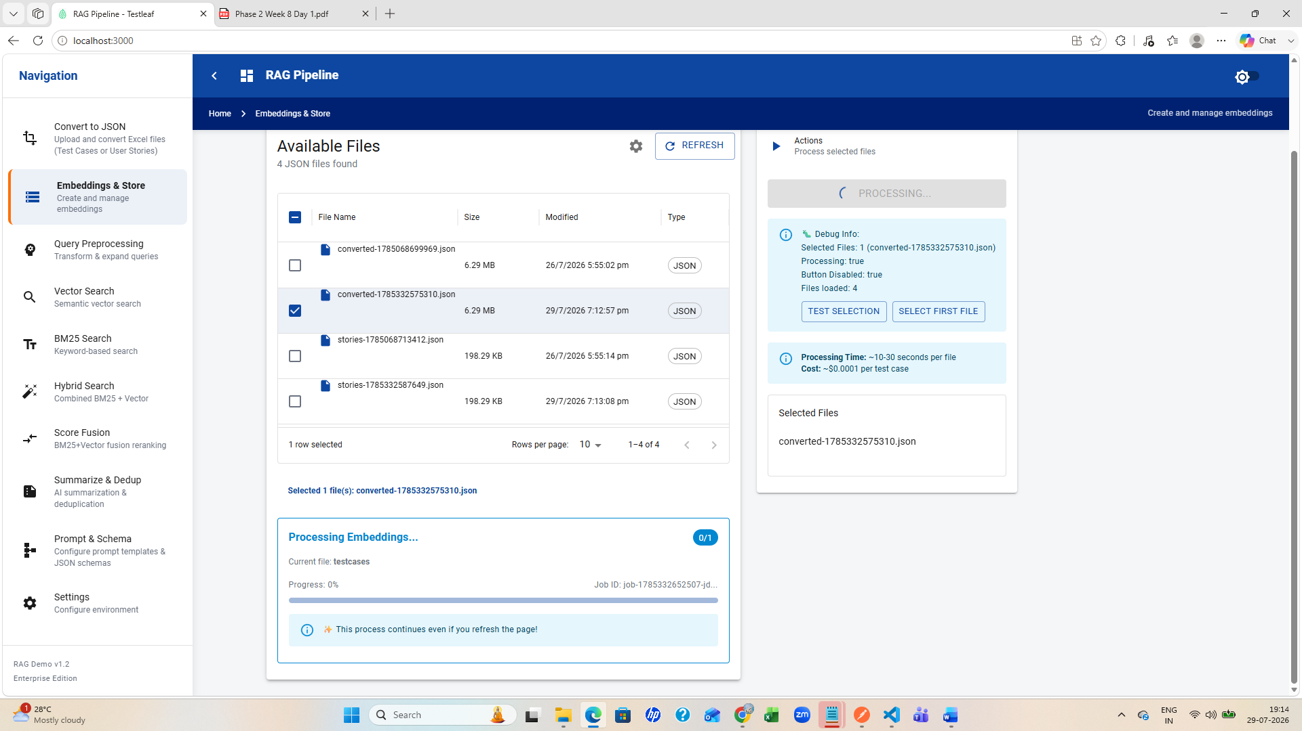
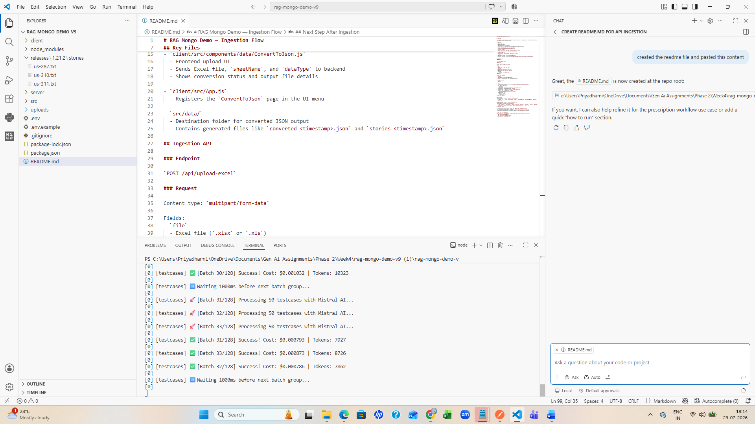
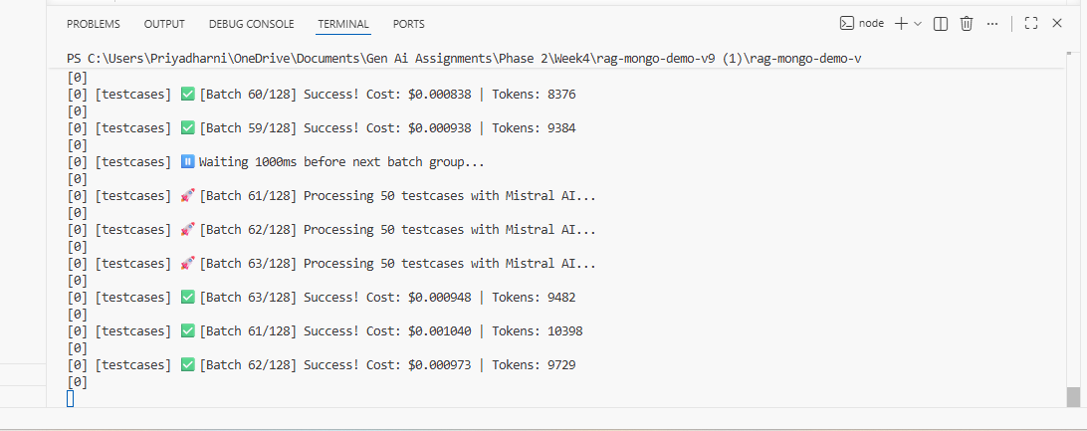
[testcases] 🚀 [Batch 112/128] Processing 50 testcases with Mistral AI...
[0]
[0] [testcases] 🚀 [Batch 113/128] Processing 50 testcases with Mistral AI...
[0]
[0] [testcases] 🚀 [Batch 114/128] Processing 50 testcases with Mistral AI...
[0]
[0] [testcases] ✅ [Batch 113/128] Success! Cost: $0.000815 | Tokens: 8149
[0]
[0] [testcases] ✅ [Batch 112/128] Success! Cost: $0.000762 | Tokens: 7622
[0]
[0] [testcases] ✅ [Batch 114/128] Success! Cost: $0.000832 | Tokens: 8324
[0]
[0] [testcases] ⏸️ Waiting 1000ms before next batch group...
[0]
[0] [testcases] 🚀 [Batch 115/128] Processing 50 testcases with Mistral AI...
[0]
[0] [testcases] 🚀 [Batch 116/128] Processing 50 testcases with Mistral AI...
[0]
[0] [testcases] 🚀 [Batch 117/128] Processing 50 testcases with Mistral AI...
[0]
[0] [testcases] ✅ [Batch 115/128] Success! Cost: $0.000858 | Tokens: 8580
[0]
[0] [testcases] ✅ [Batch 116/128] Success! Cost: $0.000896 | Tokens: 8956
[0]
[0] [testcases] ✅ [Batch 117/128] Success! Cost: $0.000821 | Tokens: 8205
[0]
[0] [testcases] 📊 Progress: 5750/6354 (90.5%) | Rate: 51.5/sec | ETA: 12s | Cost: $0.107117
[0]
[0] [testcases] ⏸️ Waiting 1000ms before next batch group...
[0]
[0] [testcases] 🚀 [Batch 118/128] Processing 50 testcases with Mistral AI...
[0]
[0] [testcases] 🚀 [Batch 119/128] Processing 50 testcases with Mistral AI...
[0]
[0] [testcases] 🚀 [Batch 120/128] Processing 50 testcases with Mistral AI...
[0]
[0] [testcases] ✅ [Batch 120/128] Success! Cost: $0.000812 | Tokens: 8124
[0]
[0] [testcases] ✅ [Batch 119/128] Success! Cost: $0.000816 | Tokens: 8163
[0]
[0] [testcases] ✅ [Batch 118/128] Success! Cost: $0.000787 | Tokens: 7873
[0]
[0] [testcases] ⏸️ Waiting 1000ms before next batch group...
[0]
[0] [testcases] 🚀 [Batch 121/128] Processing 50 testcases with Mistral AI...
[0]
[0] [testcases] 🚀 [Batch 122/128] Processing 50 testcases with Mistral AI...
[0]
[0] [testcases] 🚀 [Batch 123/128] Processing 50 testcases with Mistral AI...
[0]
[0] [testcases] ✅ [Batch 123/128] Success! Cost: $0.000852 | Tokens: 8520
[0]
[0] [testcases] ✅ [Batch 121/128] Success! Cost: $0.000841 | Tokens: 8413
[0]
[0] [testcases] ✅ [Batch 122/128] Success! Cost: $0.000882 | Tokens: 8820
[0]
[0] [testcases] ⏸️ Waiting 1000ms before next batch group...
[0]
[0] [testcases] 🚀 [Batch 124/128] Processing 50 testcases with Mistral AI...
[0]
[0] [testcases] 🚀 [Batch 125/128] Processing 50 testcases with Mistral AI...
[0]
[0] [testcases] 🚀 [Batch 126/128] Processing 50 testcases with Mistral AI...
[0]
[0] [testcases] ✅ [Batch 125/128] Success! Cost: $0.001018 | Tokens: 10183
[0]
[0] [testcases] ✅ [Batch 126/128] Success! Cost: $0.000946 | Tokens: 9461
[0]
[0] [testcases] ✅ [Batch 124/128] Success! Cost: $0.000846 | Tokens: 8458
[0]
[0] [testcases] ⏸️ Waiting 1000ms before next batch group...
[0]
[0] [testcases] 🚀 [Batch 127/128] Processing 50 testcases with Mistral AI...
[0]
[0] [testcases] 🚀 [Batch 128/128] Processing 4 testcases with Mistral AI...
[0]
[0] [testcases] ✅ [Batch 128/128] Success! Cost: $0.000074 | Tokens: 744
[0]
[0] [testcases] ✅ [Batch 127/128] Success! Cost: $0.001032 | Tokens: 10317
[0]
[0] [testcases] 📊 Progress: 6354/6354 (100.0%) | Rate: 52.5/sec | ETA: 0s | Cost: $0.117741
[0]
[0] [testcases]
[0] 🎉 MISTRAL AI BATCH PROCESSING COMPLETE!
[0]
[0] [testcases] 📊 Final Statistics:
[0] ⏱️ Total Time: 2m 2s
[0] ⚡ Processing Rate: 52.1 testcases/second
[0] 📝 Total Test Cases: 6354
[0] ✅ Successfully Processed: 6354
[0] ❌ Failed: 0
[0] 📈 Success Rate: 100.0%
[0] 💰 Total Cost: $0.117741
[0]
[0] [testcases] 🔢 Total Tokens: 11,77,411
[0] 📊 Average Cost per Test Case: $0.00001853
[0]
[0] [testcases] 📊 Average Tokens per Test Case: 185
[0] 💡 Cost Savings: ~90% cheaper than OpenAI embeddings
[0]
[0] ✅ Batch script completed successfully!
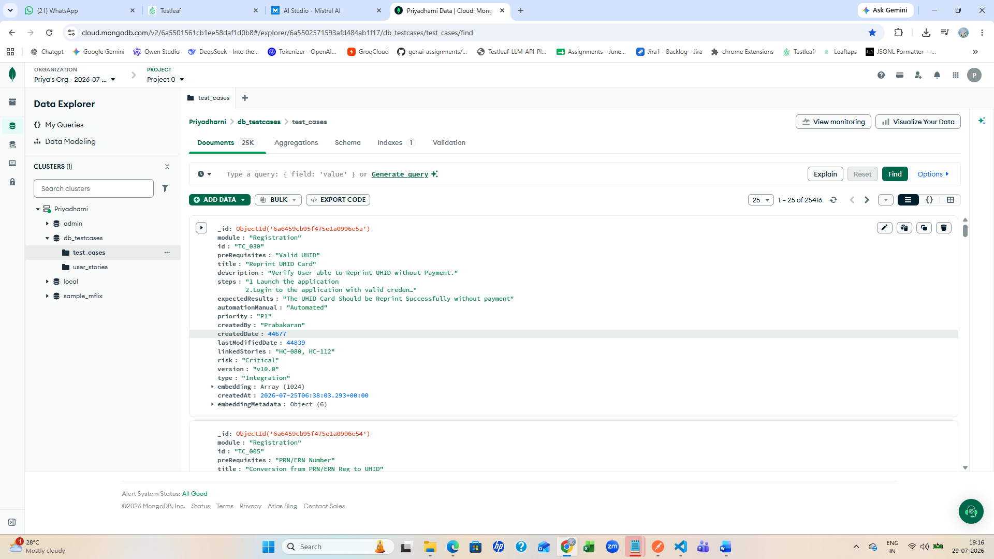
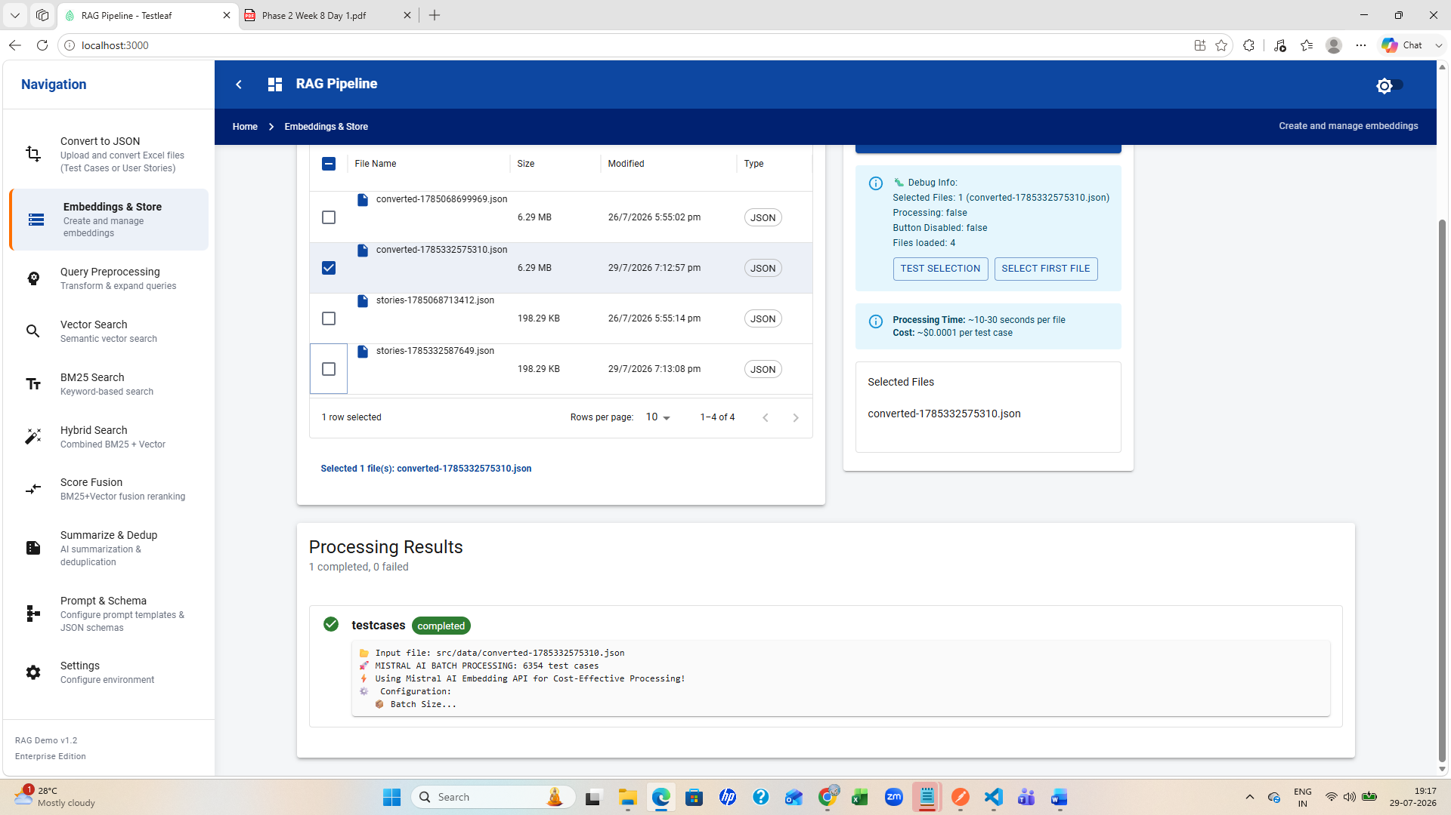

userstory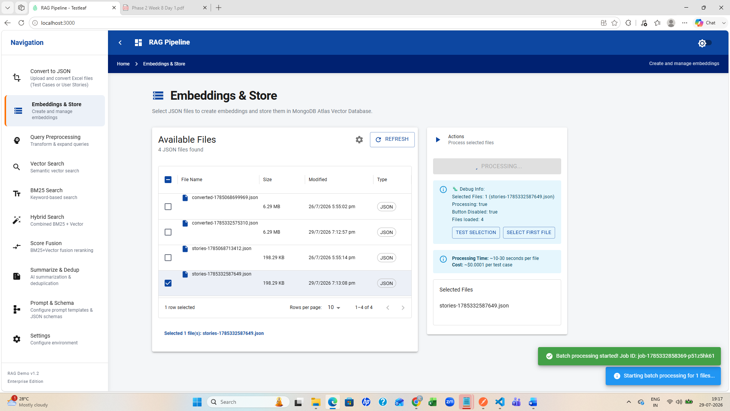
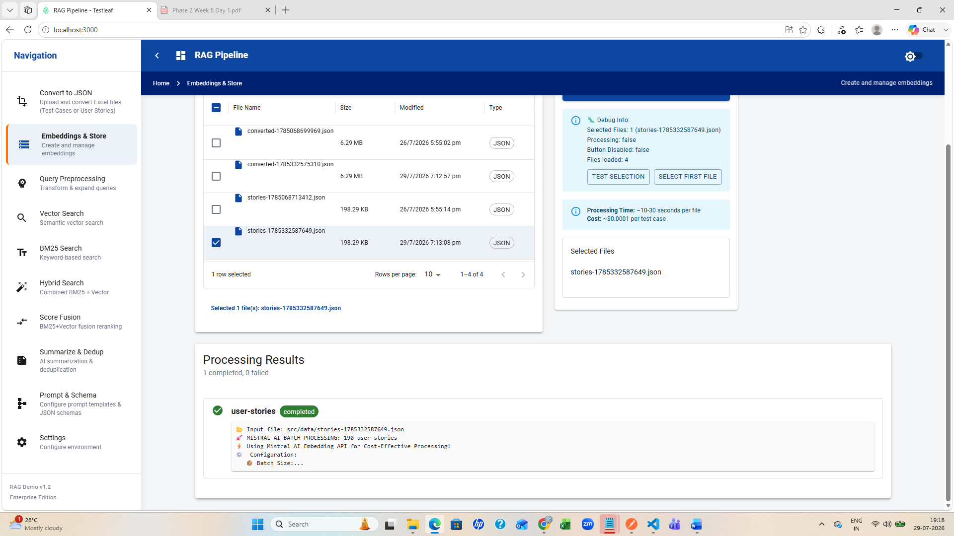
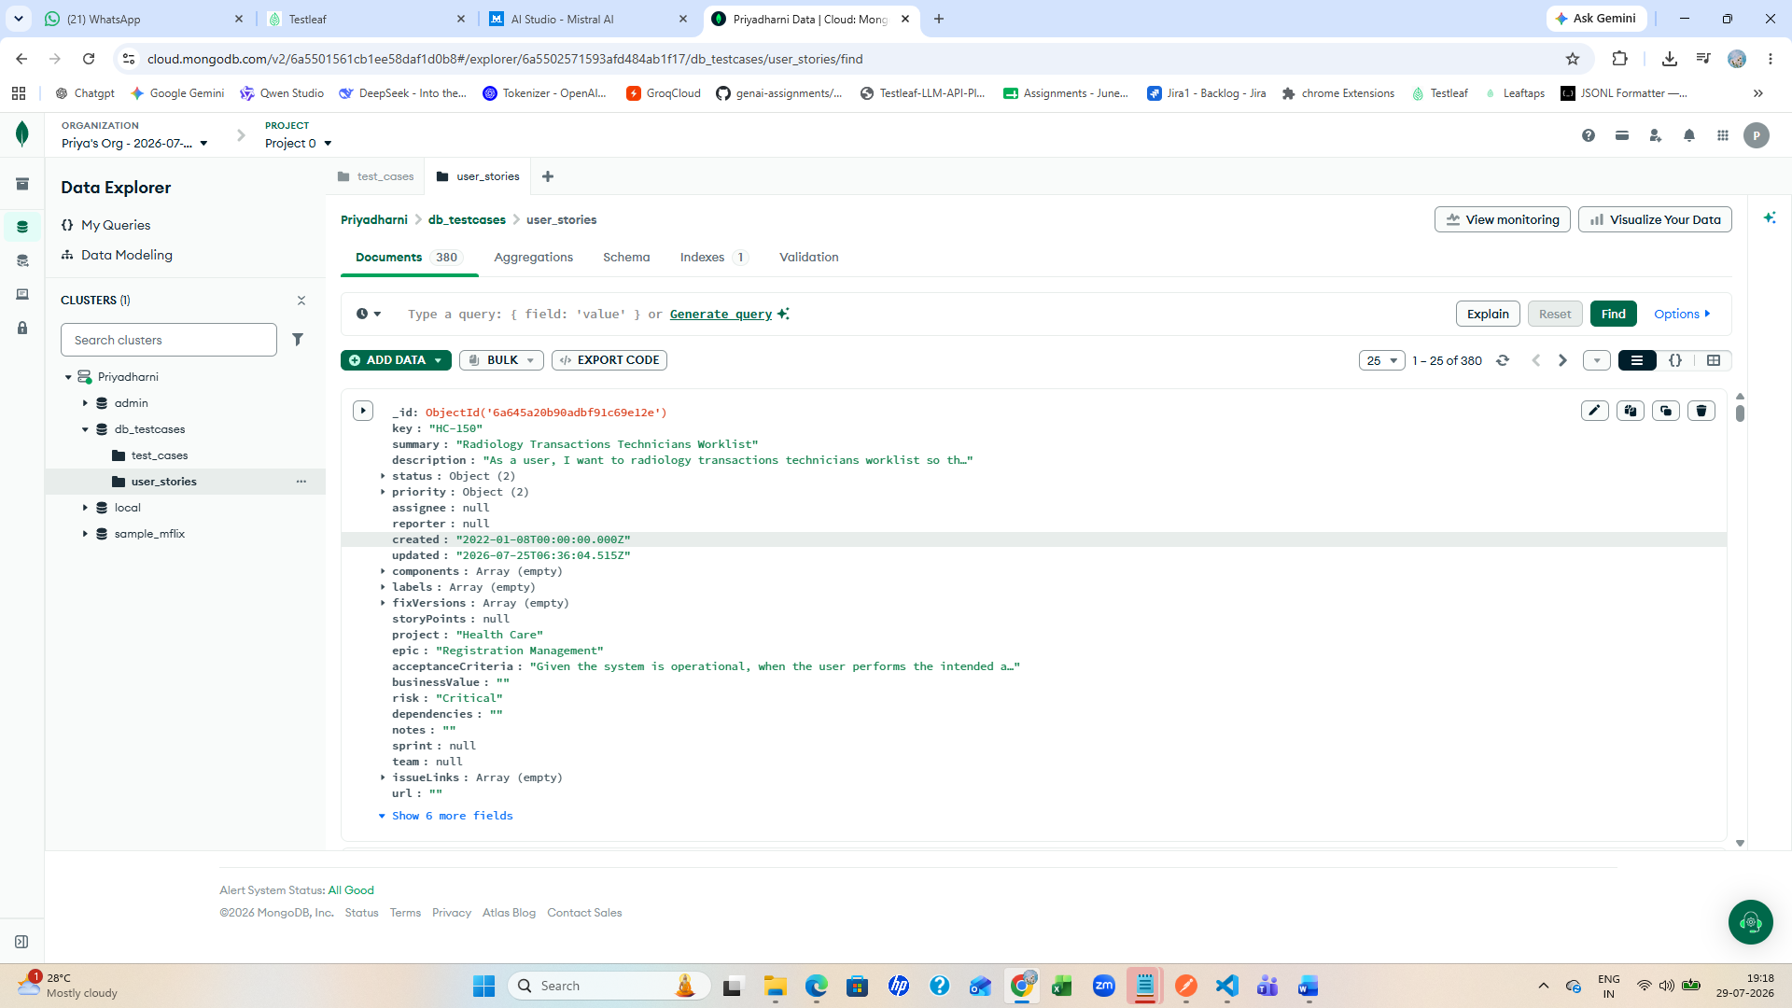
Query preprocessing
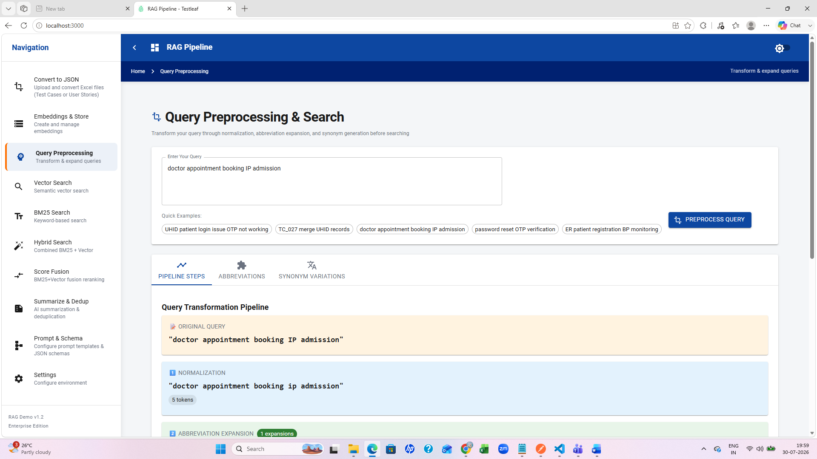
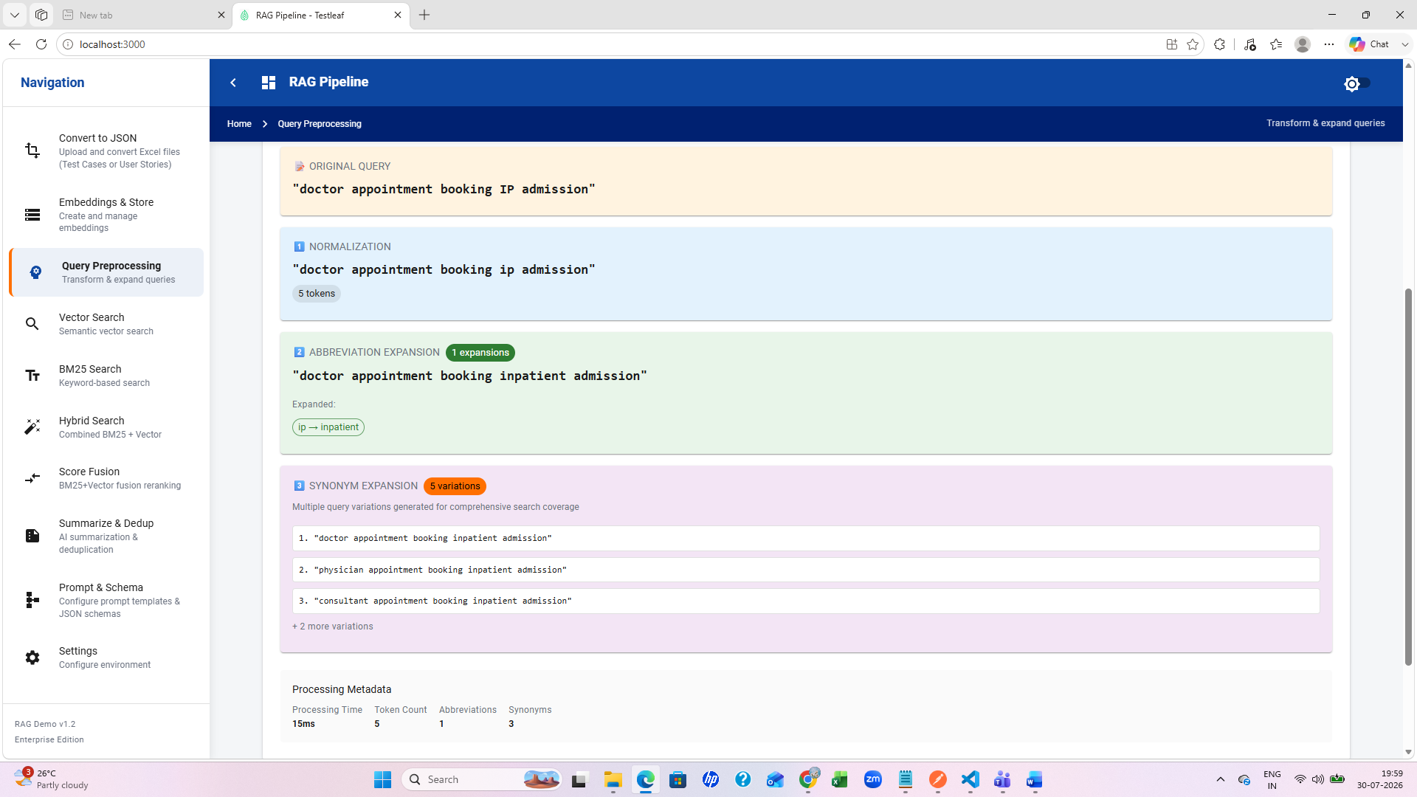

Vector search
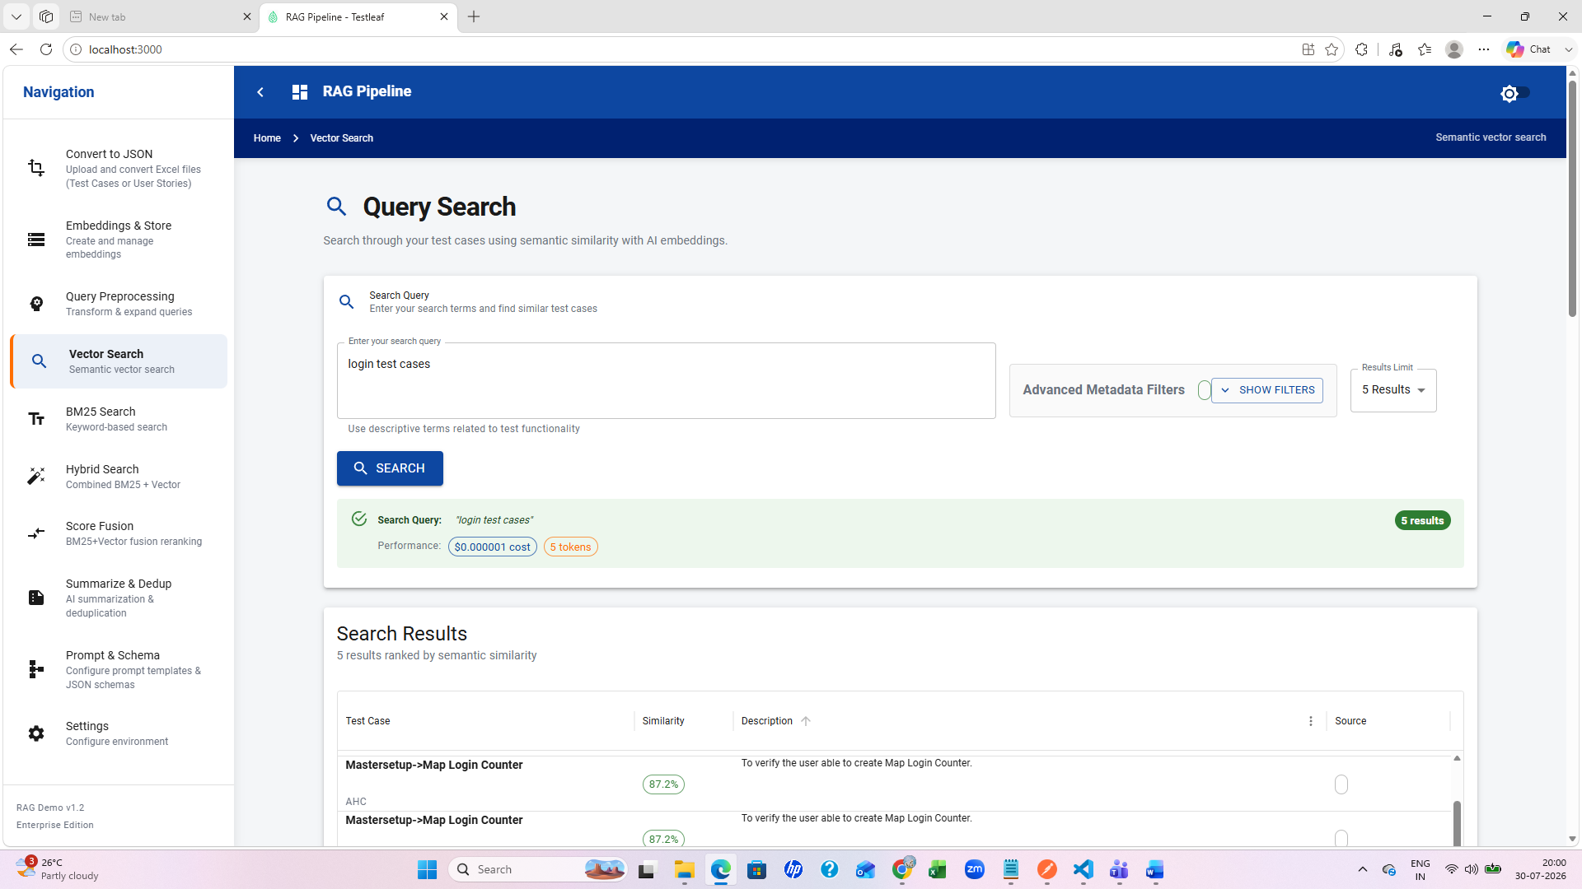
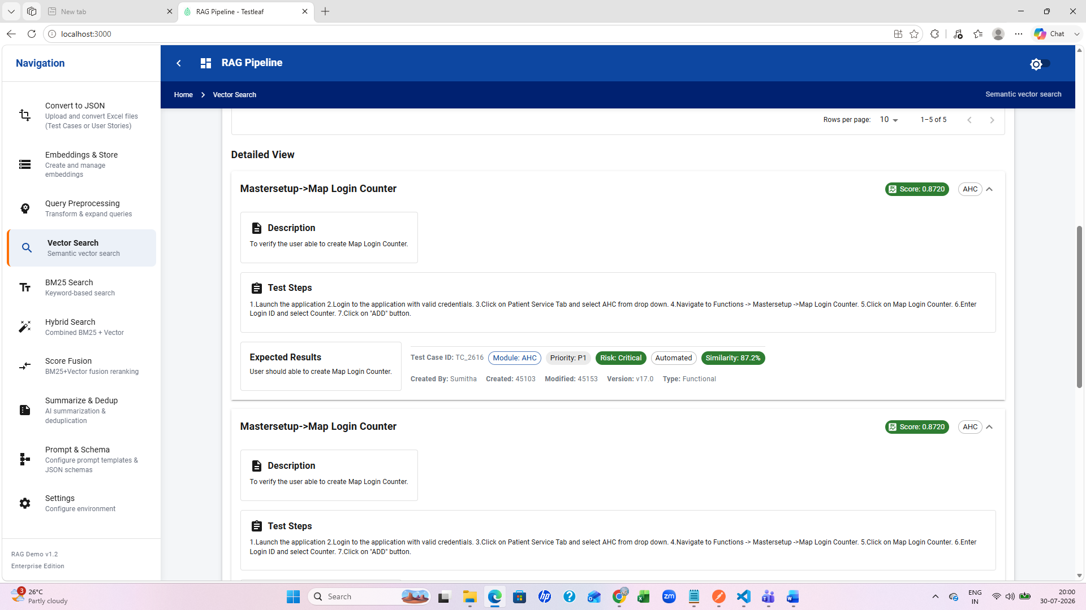
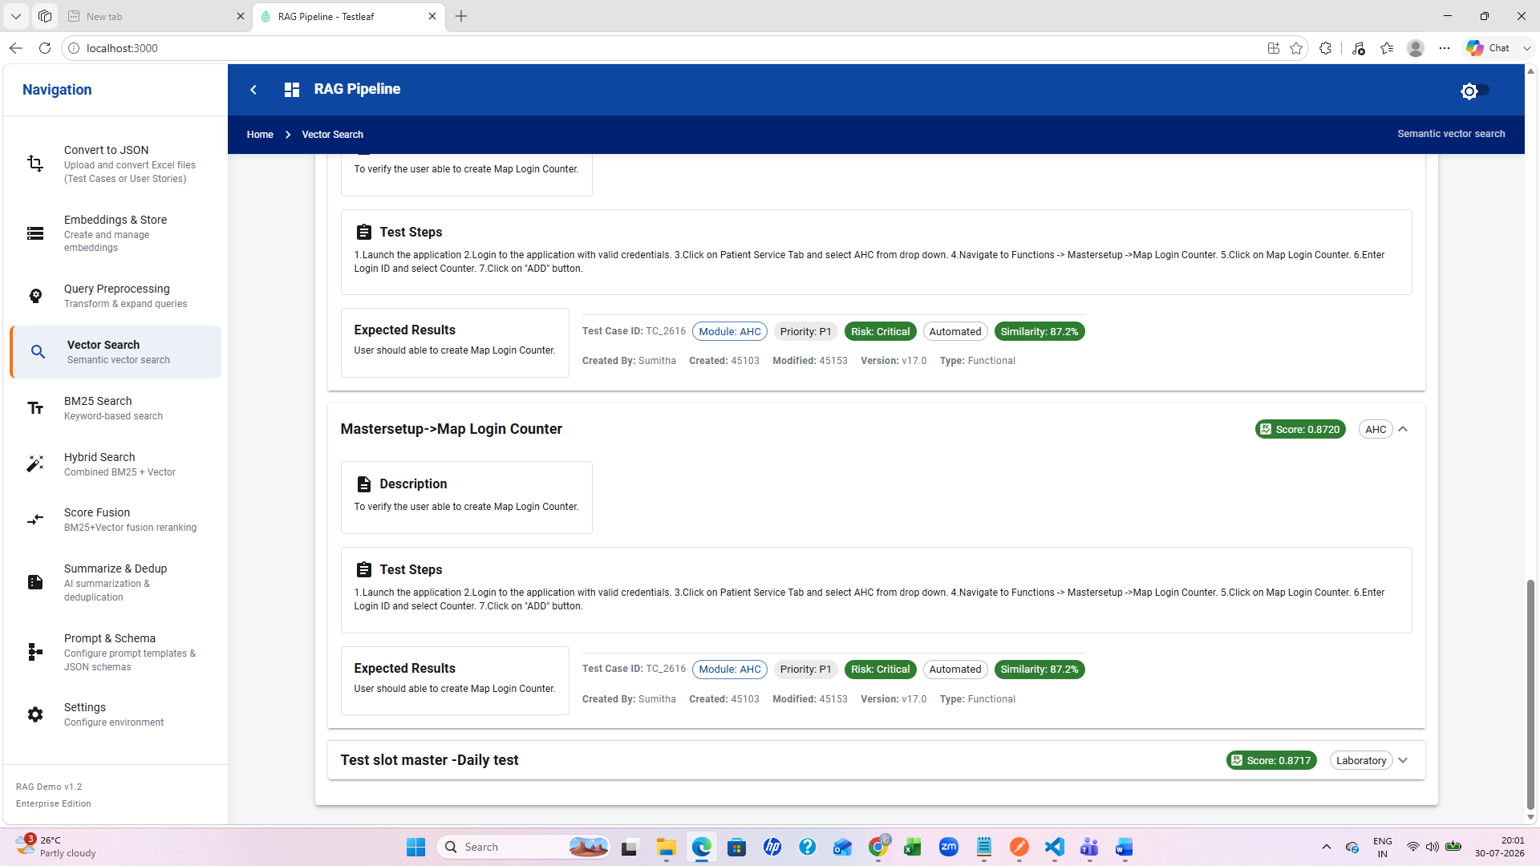
BM25 search
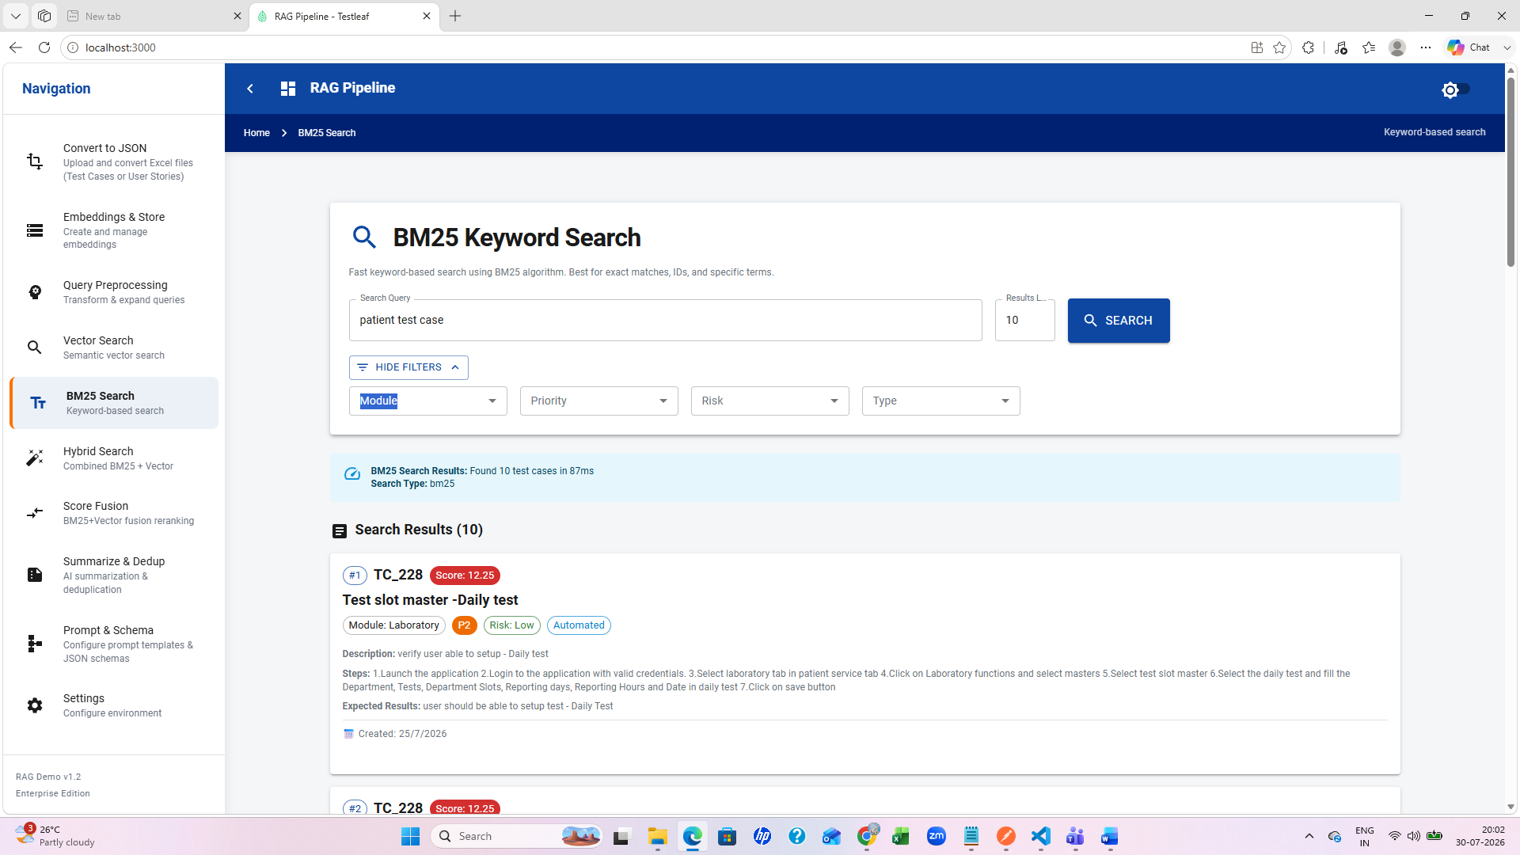
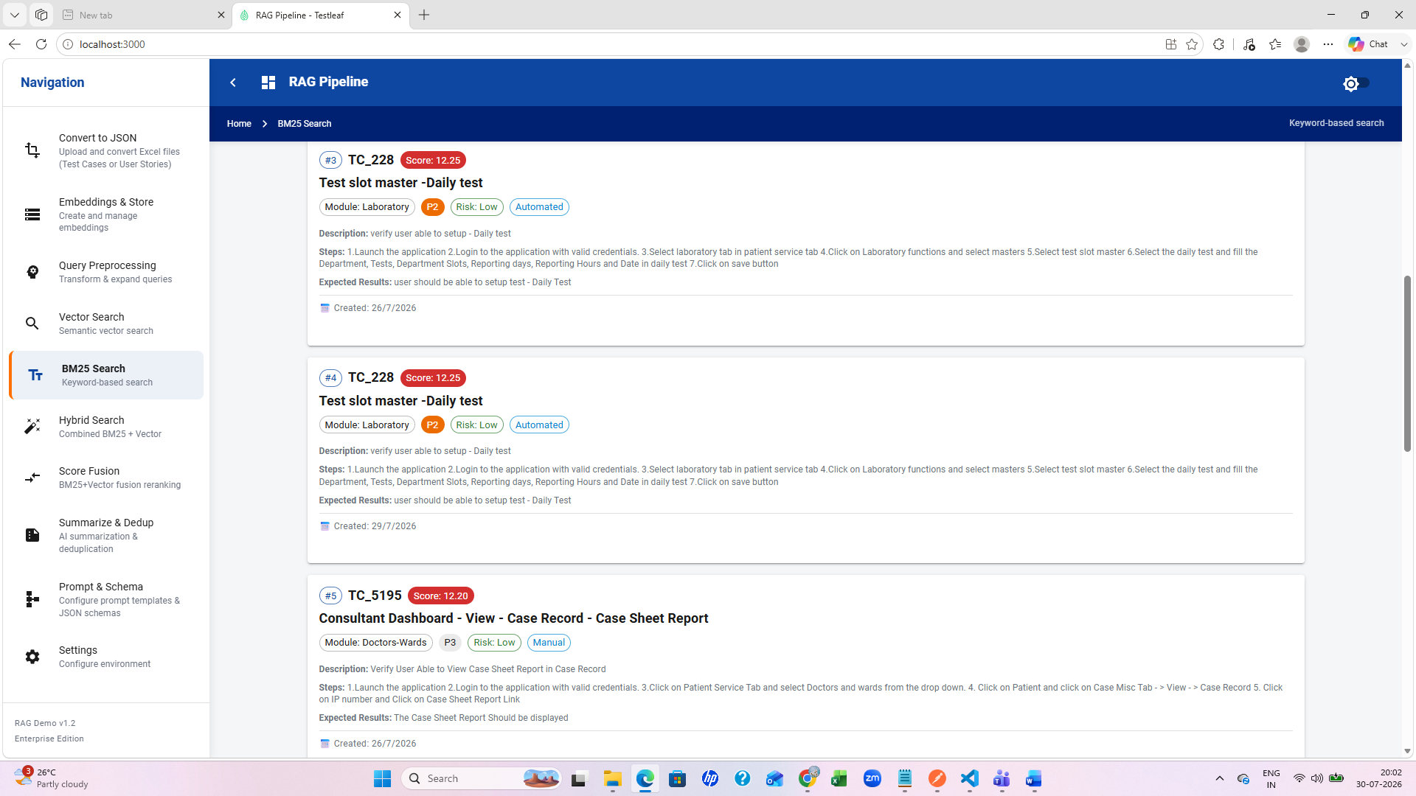
Hybrid search
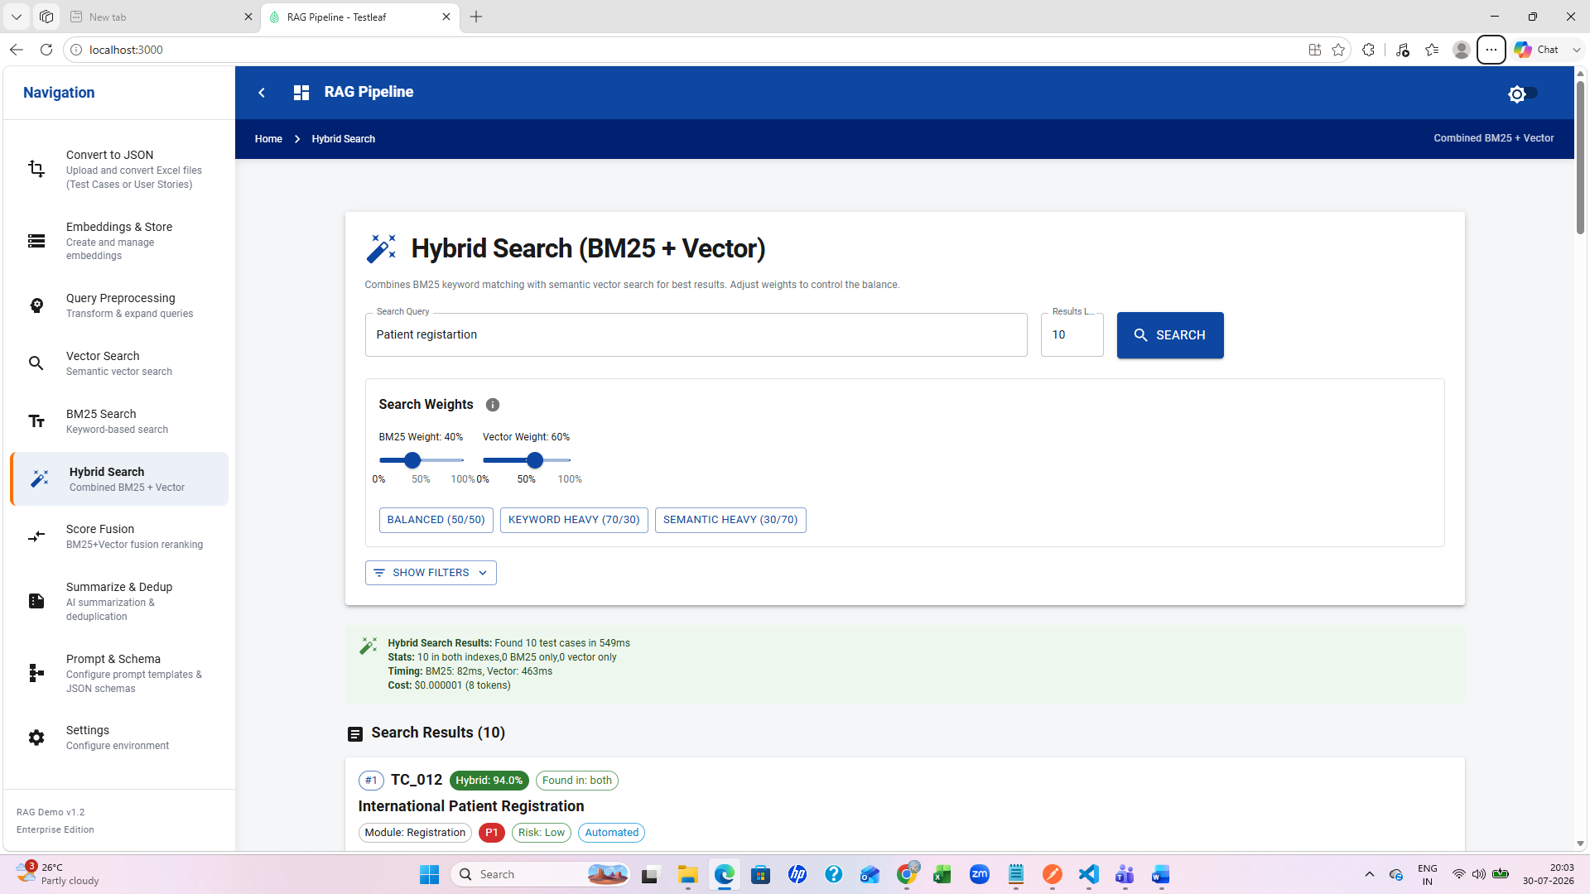
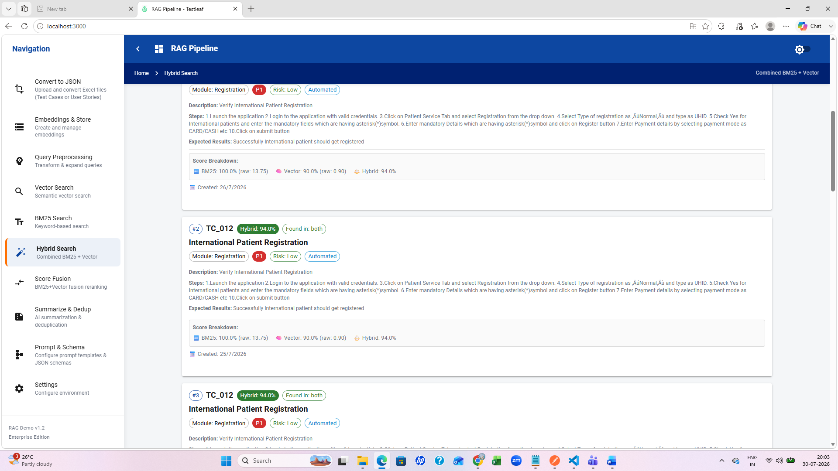
Score fusion
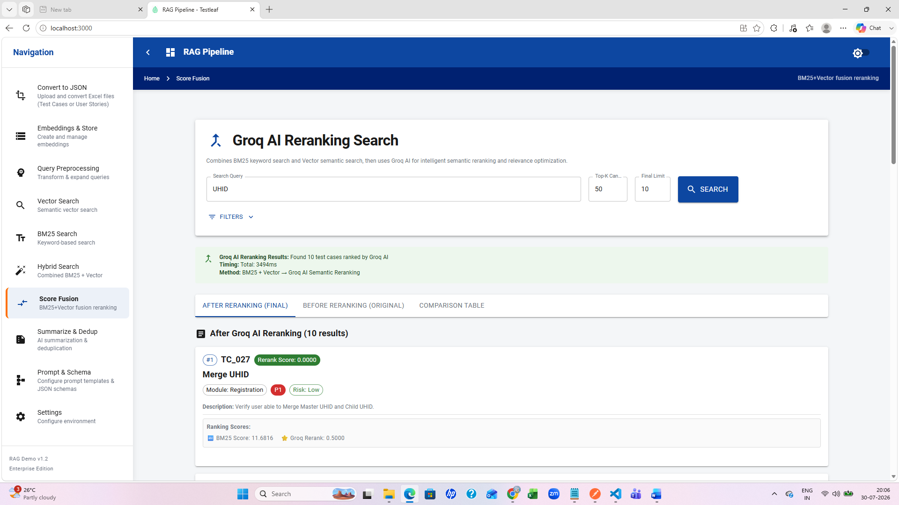
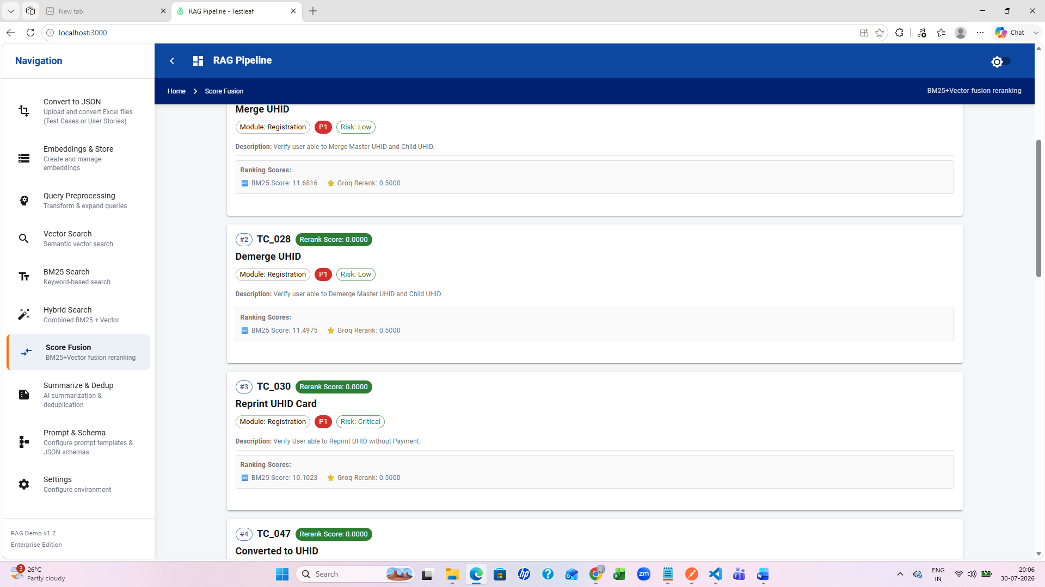
Summarize and deduplication
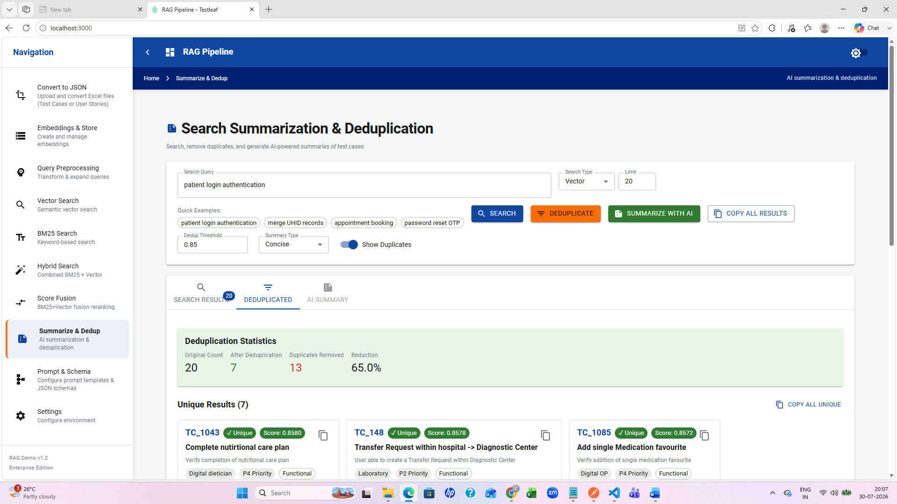
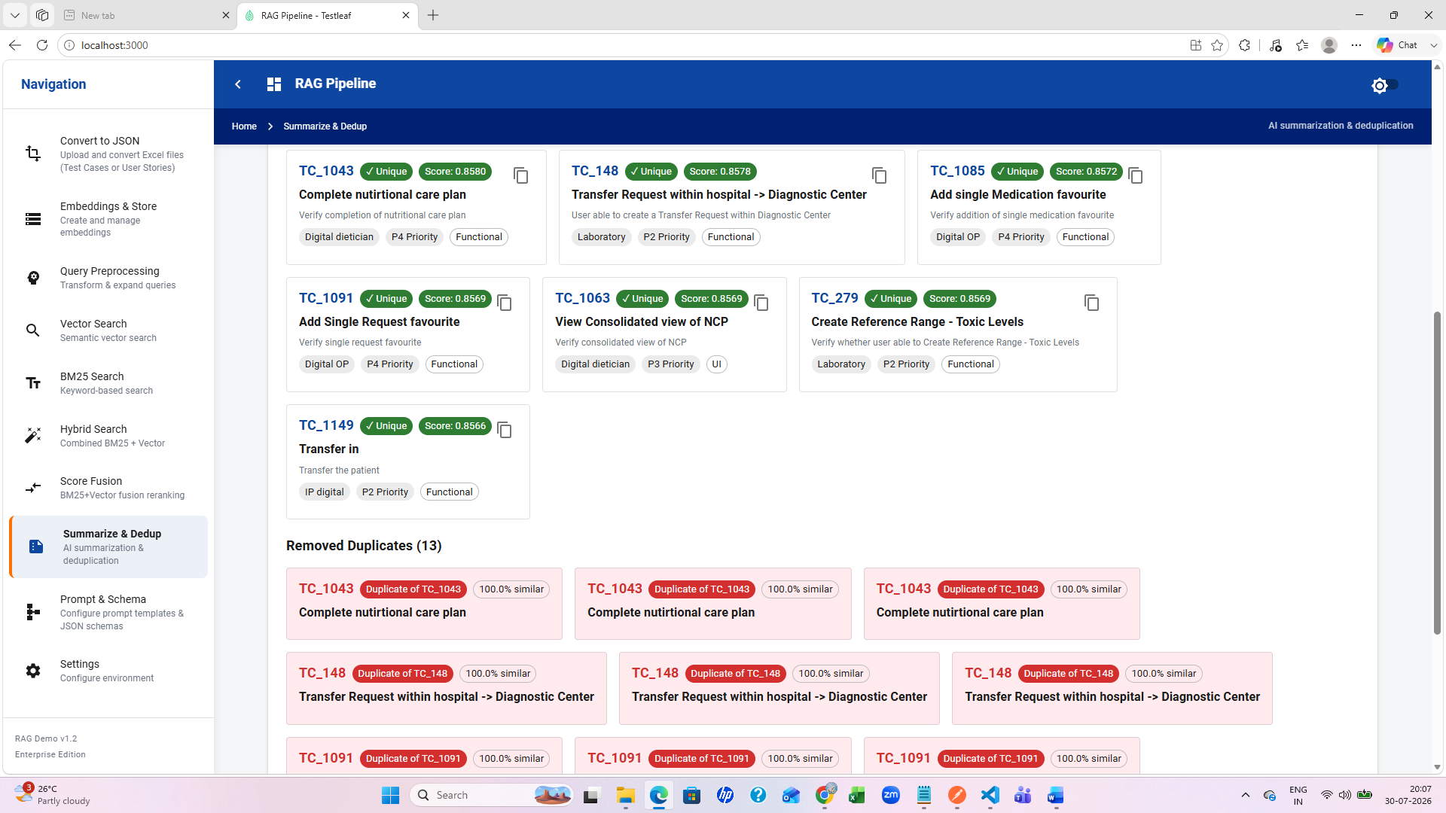

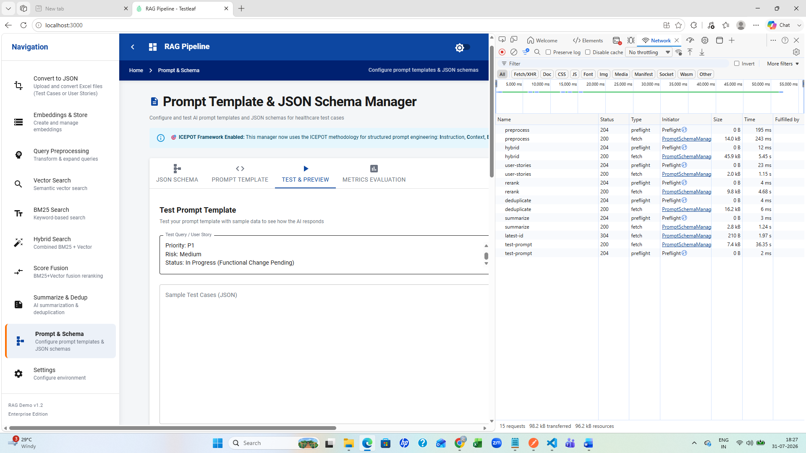
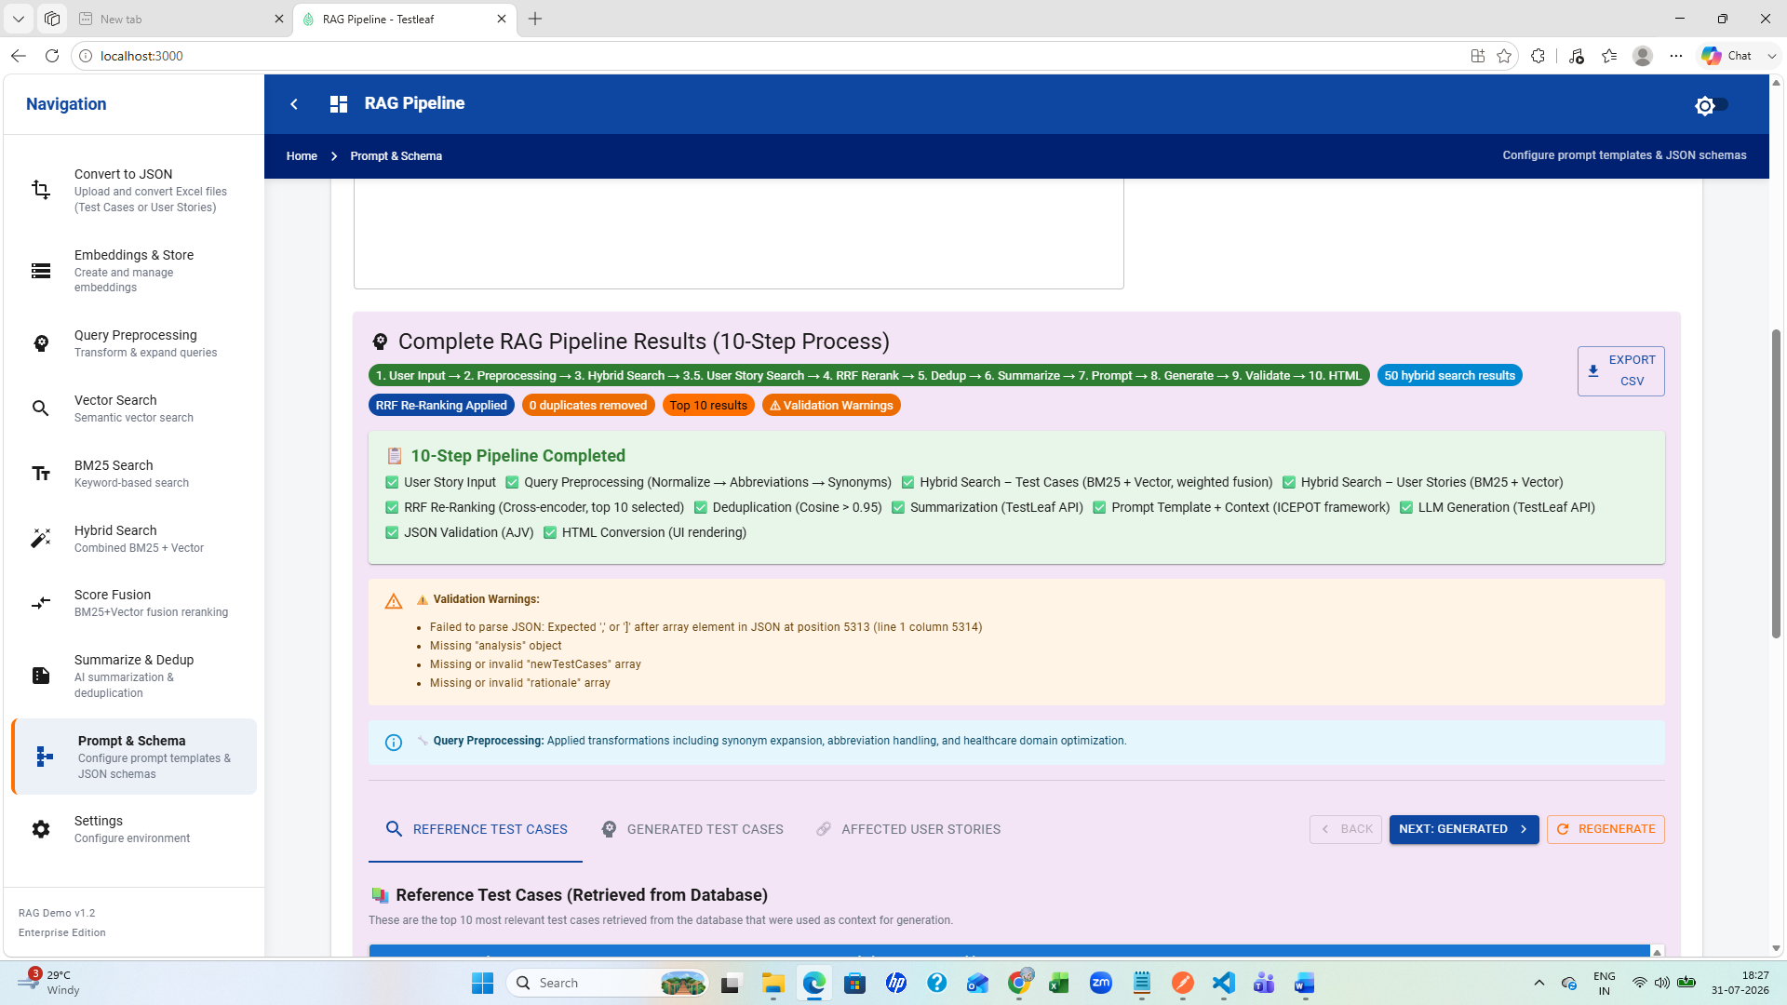
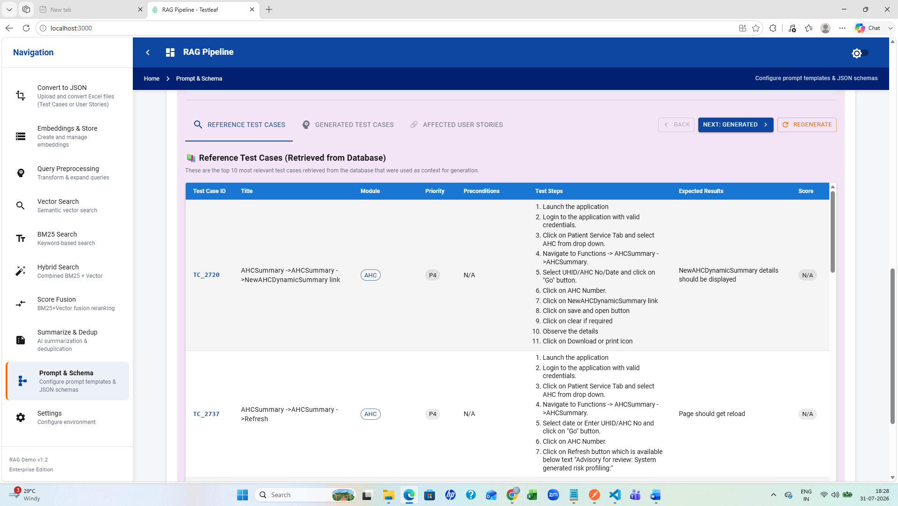
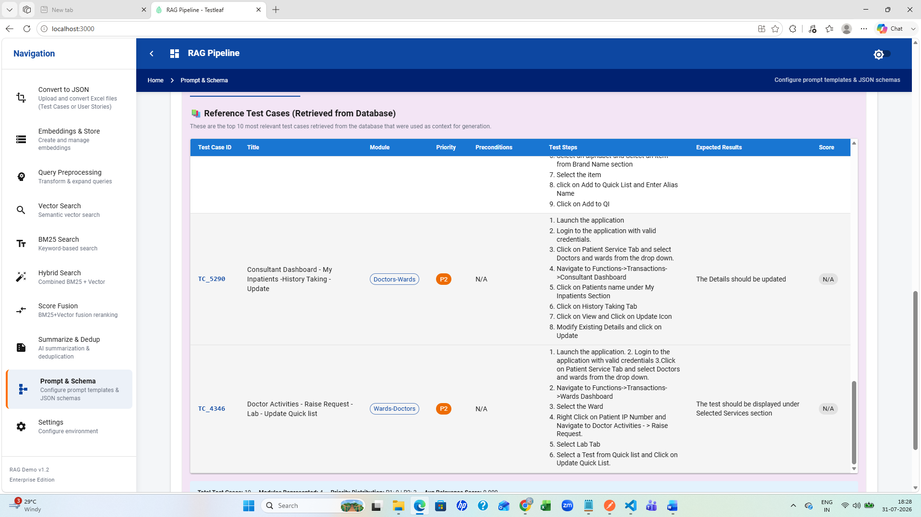

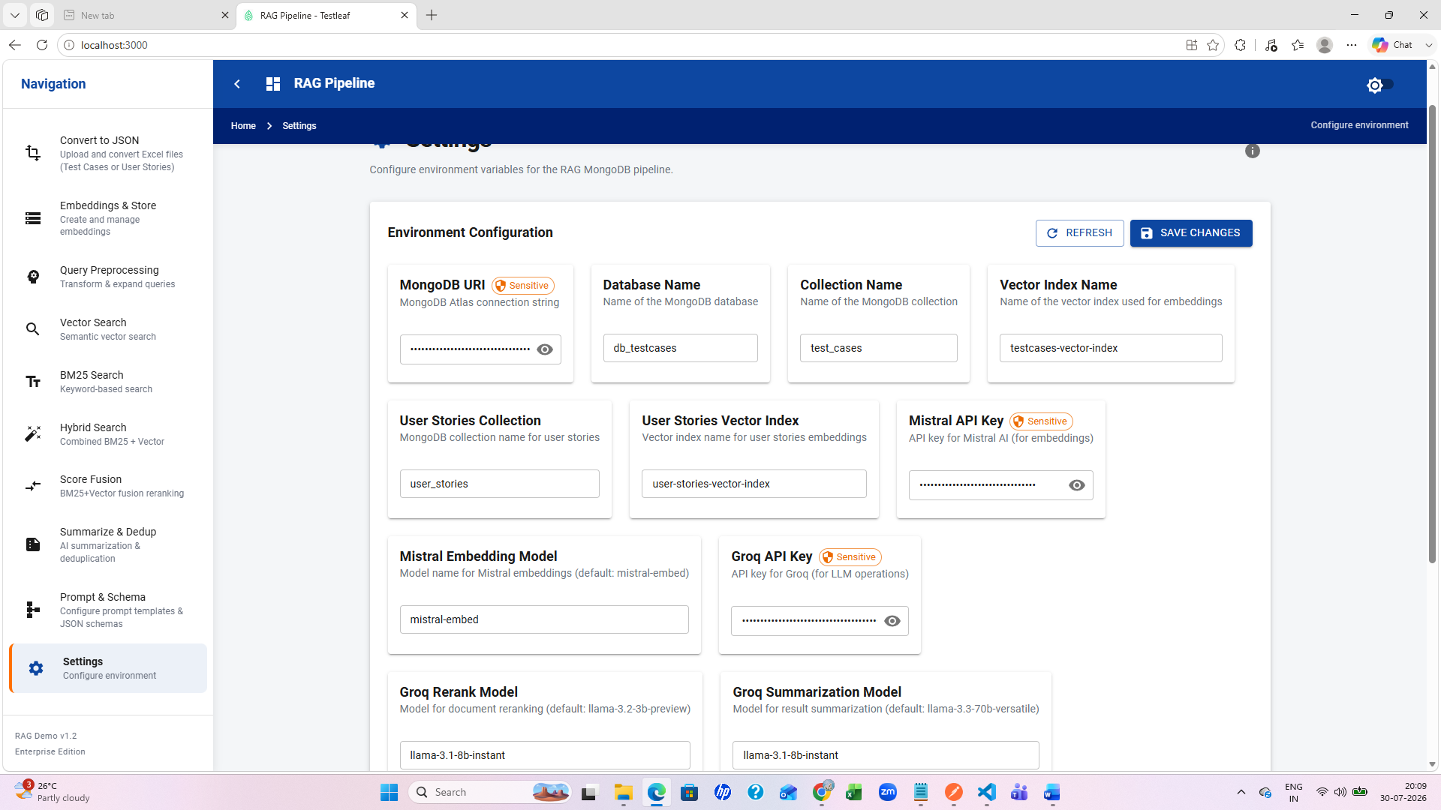

Create README.md file
Prompt gave in vs code-Generate a README.md file for RAG-MONGO-DEMO-V9
In the project root folder right click->new file->README.md
From the vs code generated README file copy the content and save it
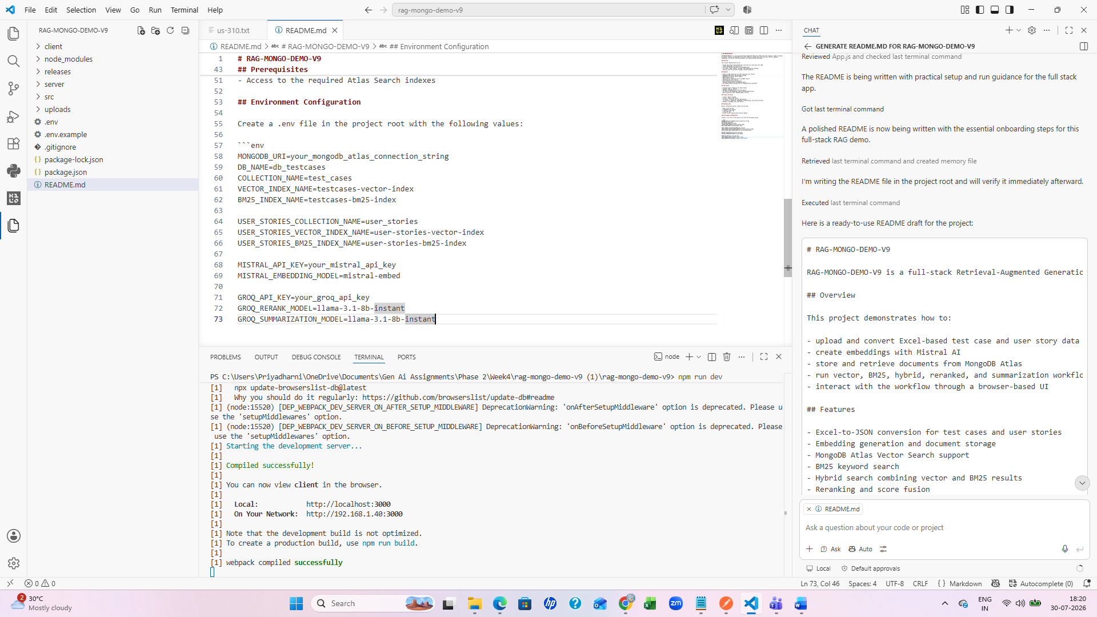
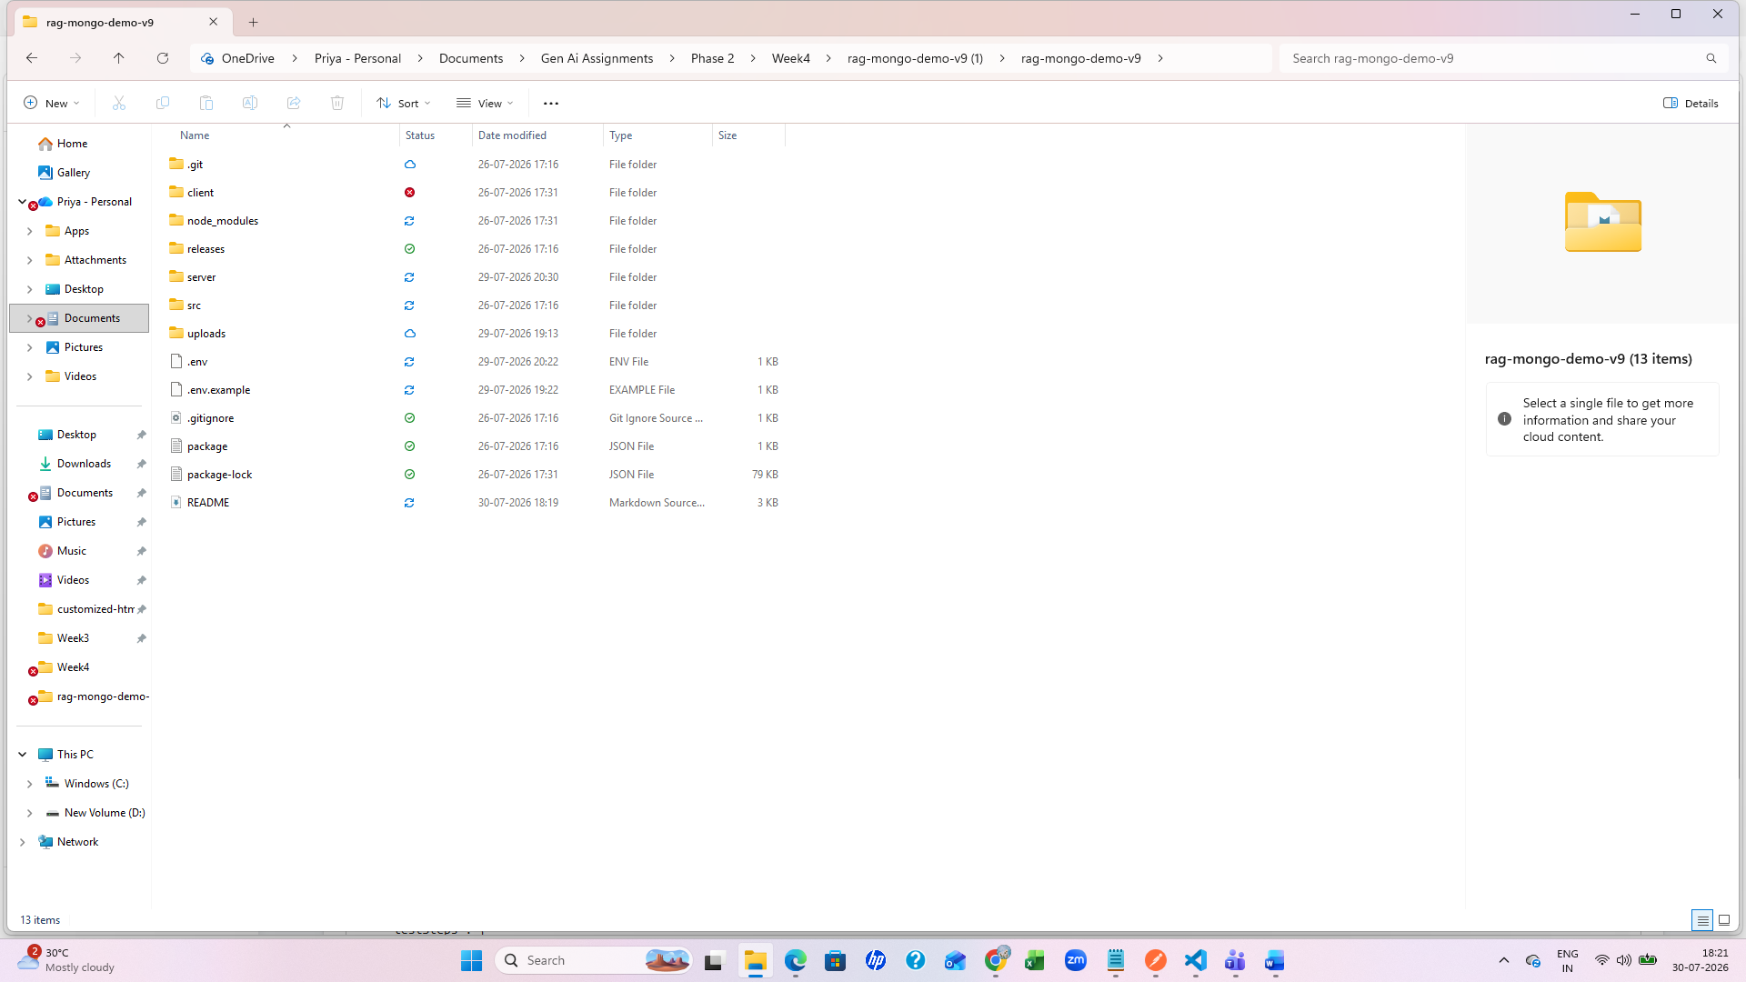
Updated the README.md file
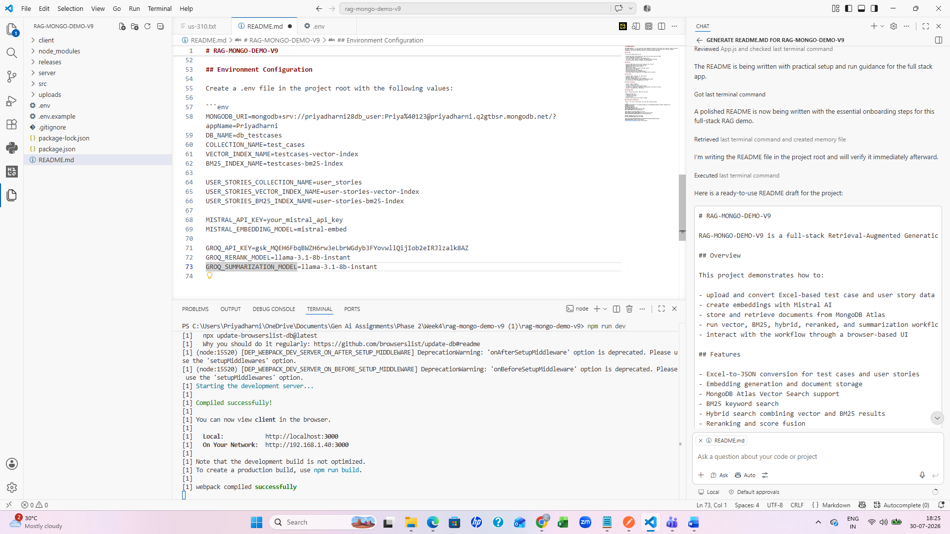

RAG backend api collection
- Upload excel file
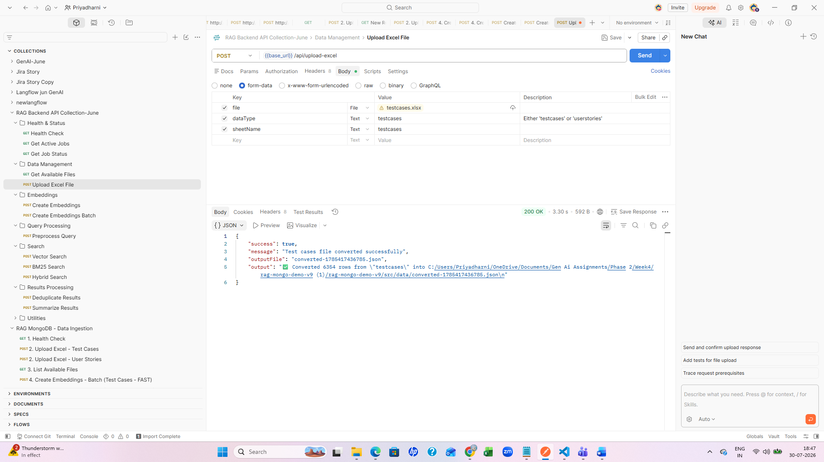
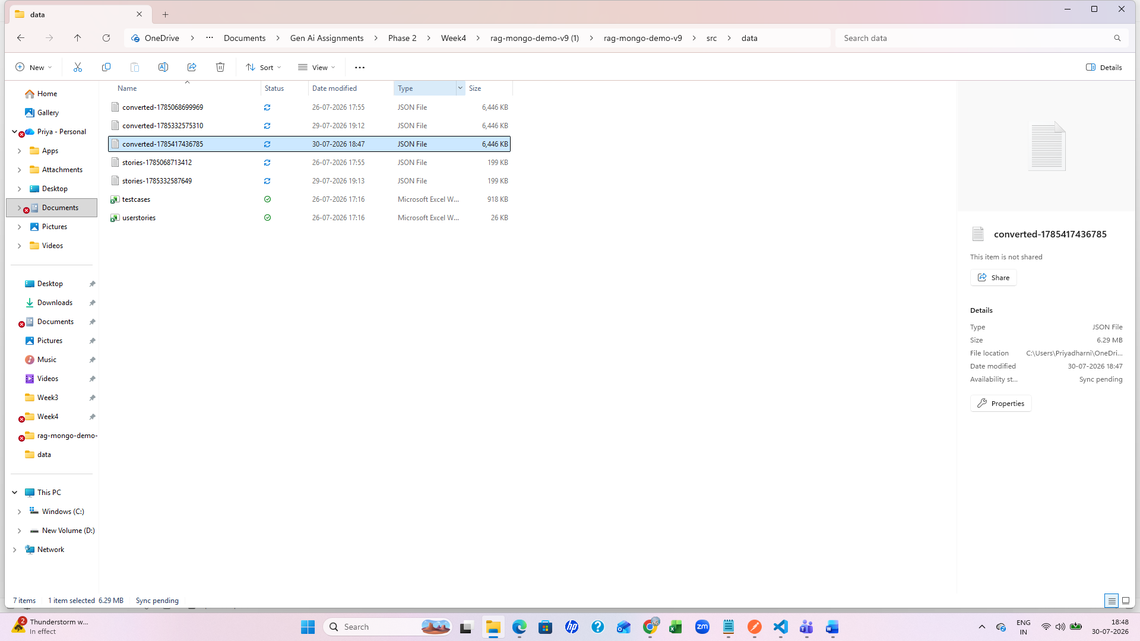
2. Create embeddings
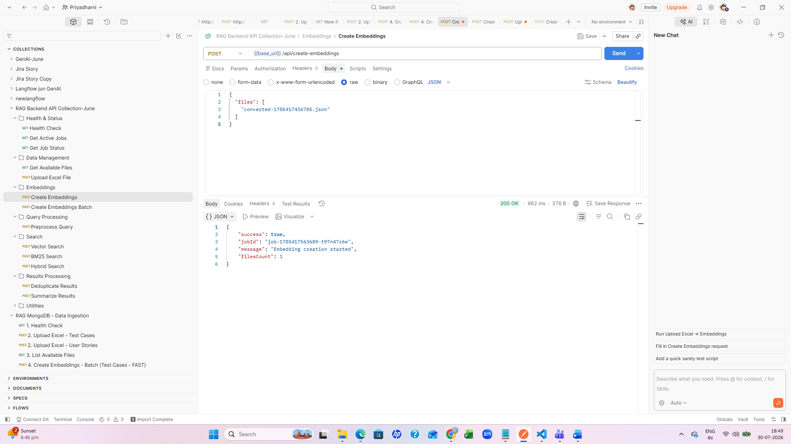
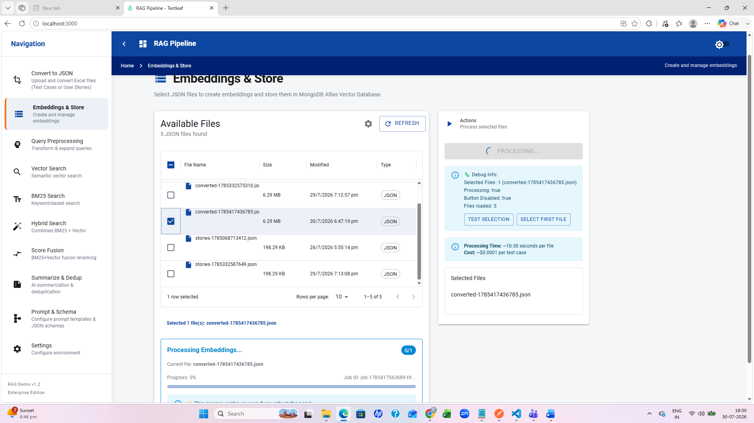
3.Preproccesing query
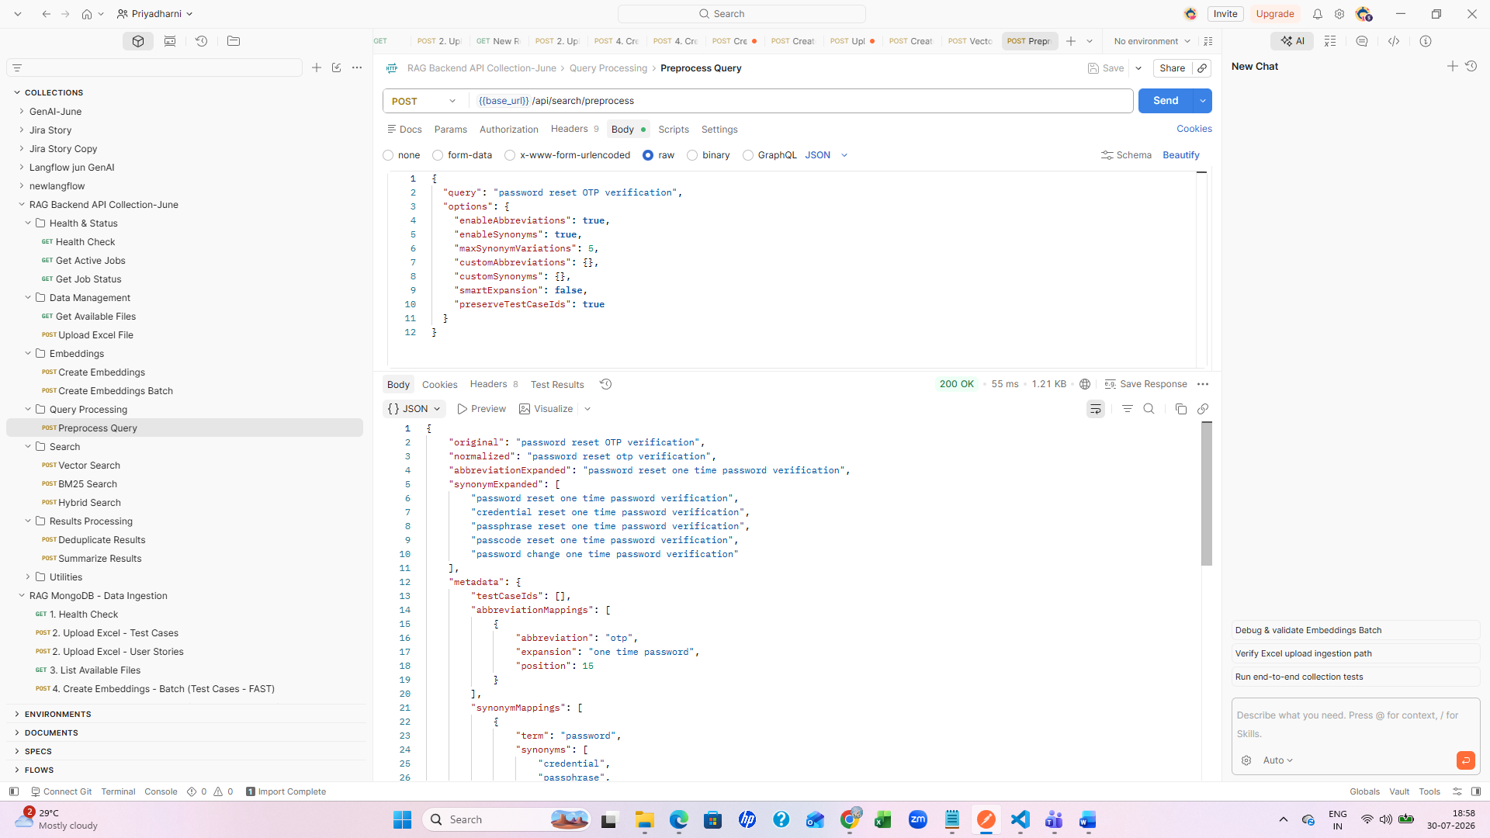
4. vector search
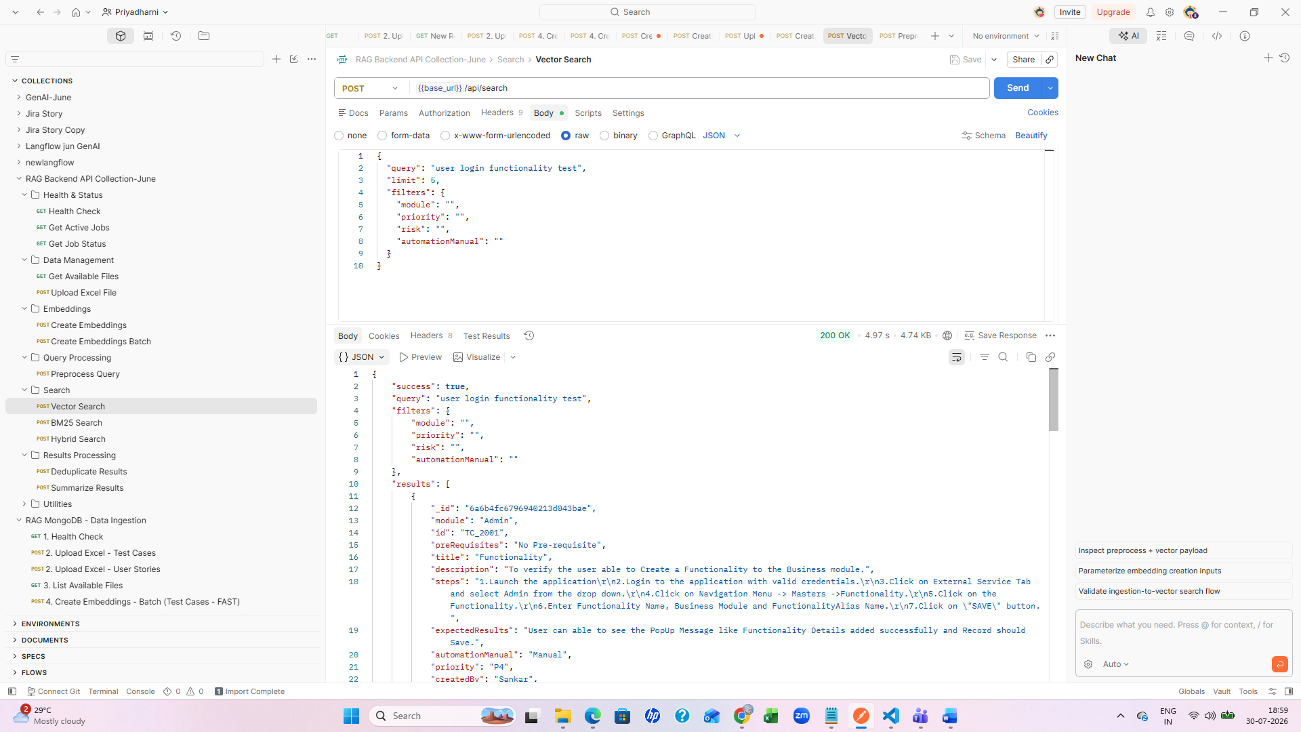
5. BM25 search
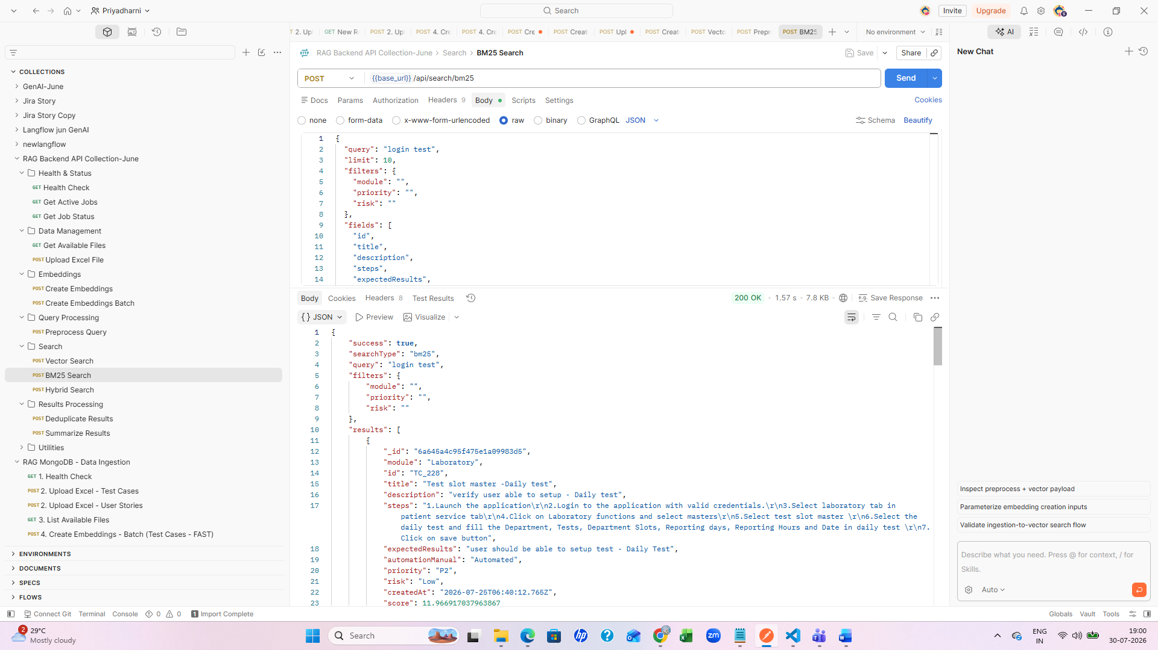
6. deduplicate results
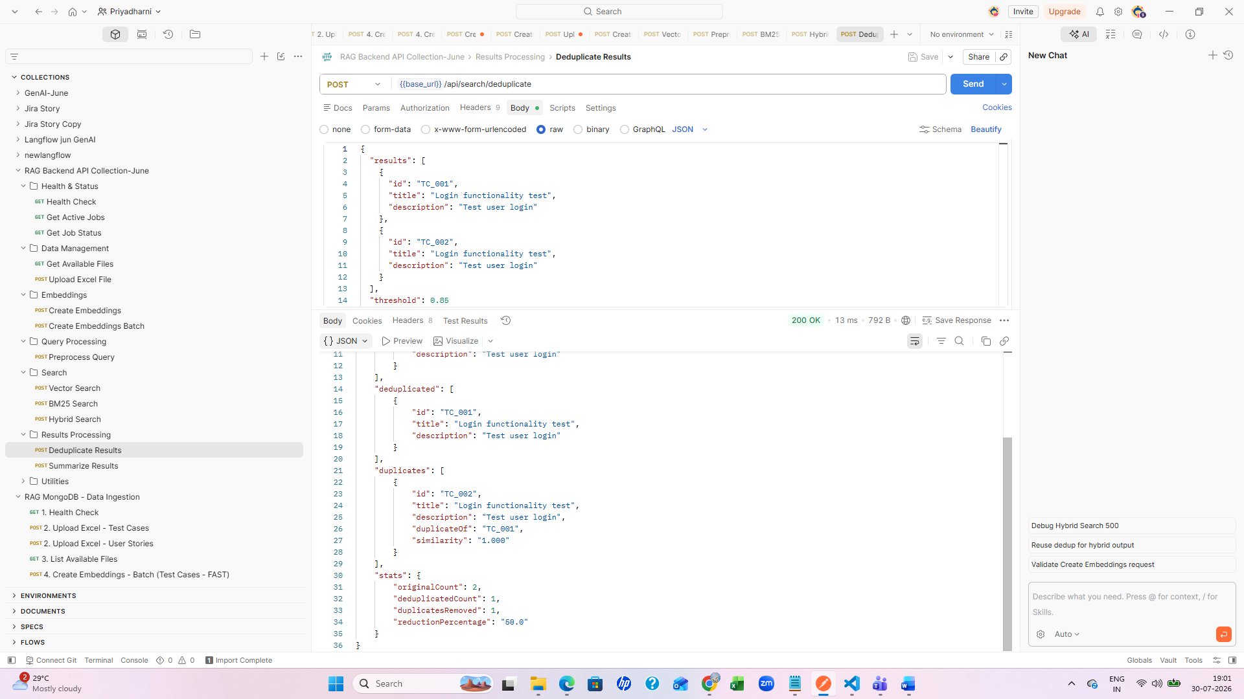

Cohere
Prompt - Give the API postman collection for https://docs.cohere.com/reference/embed with different possible inputs like images etc with different request
Created new cohere api key

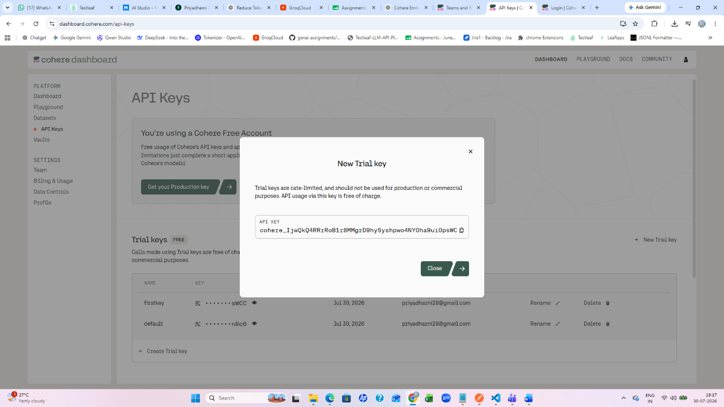
added new api key
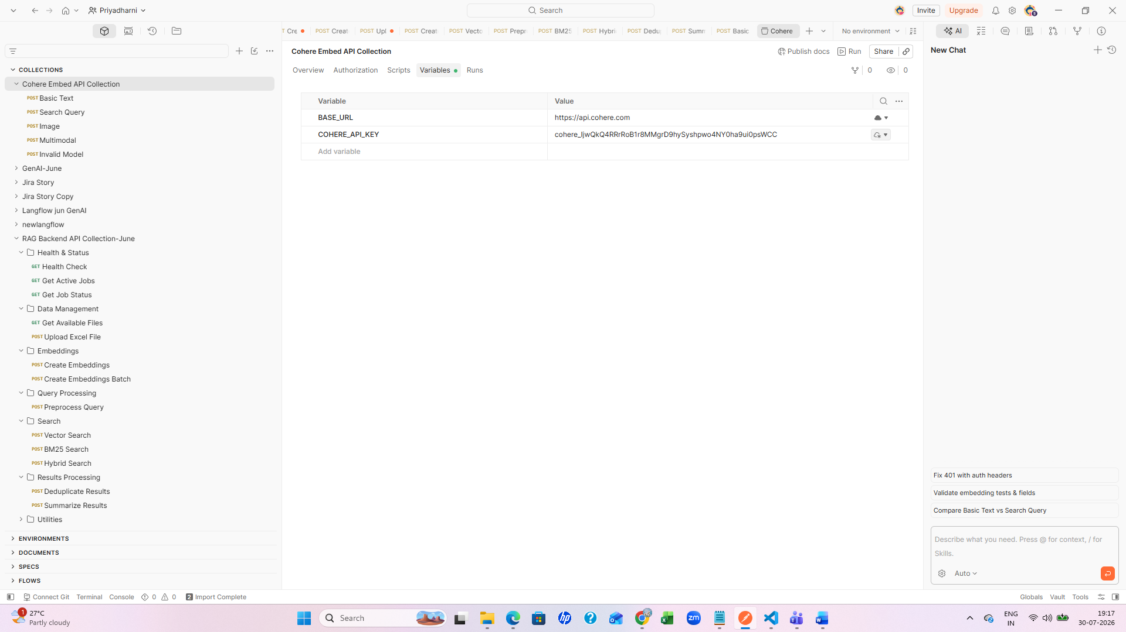

Basic text
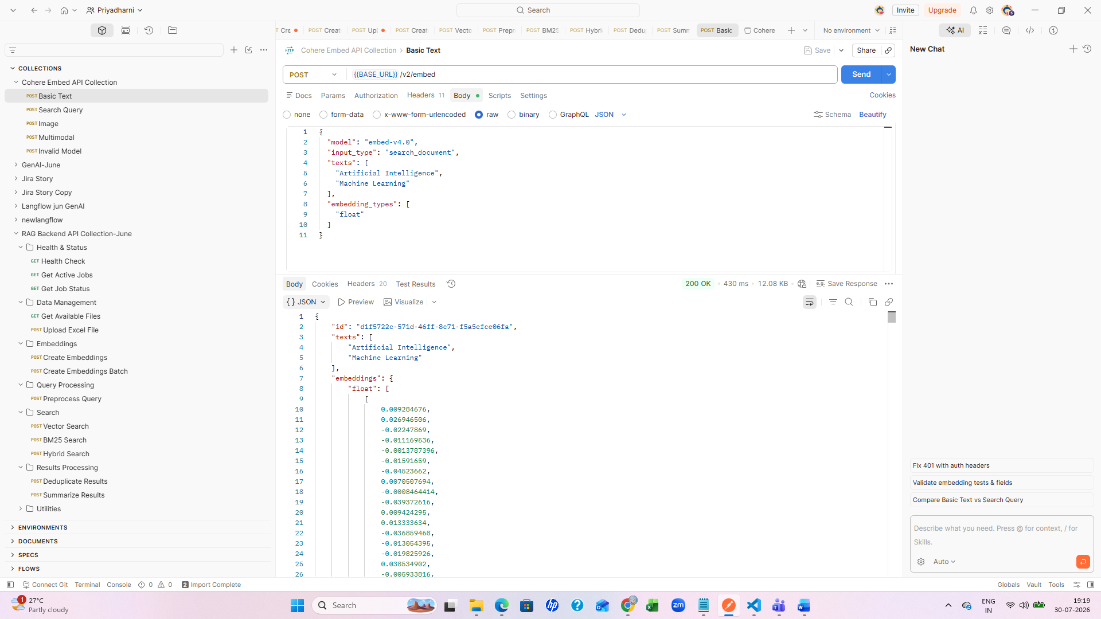
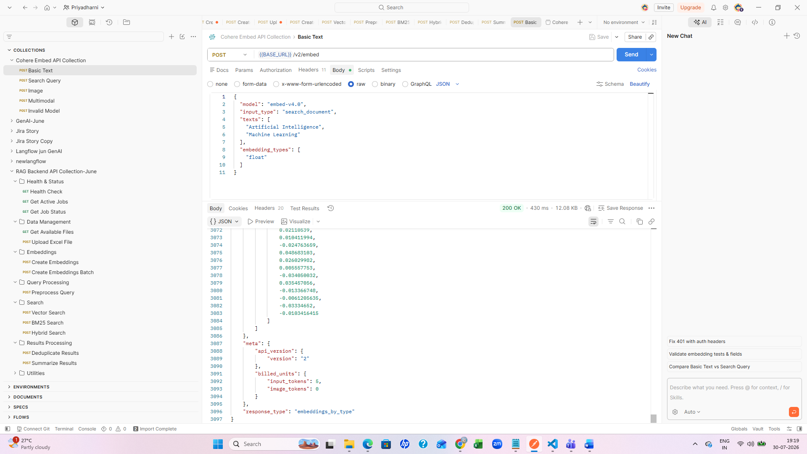
Search query
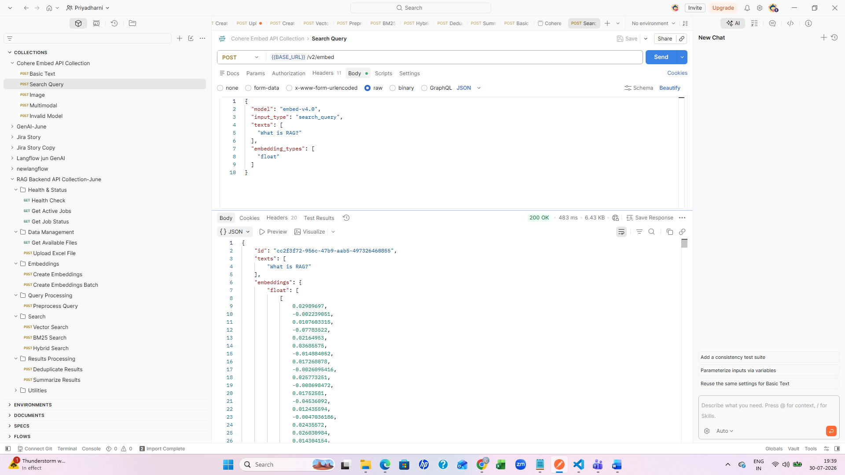
Image
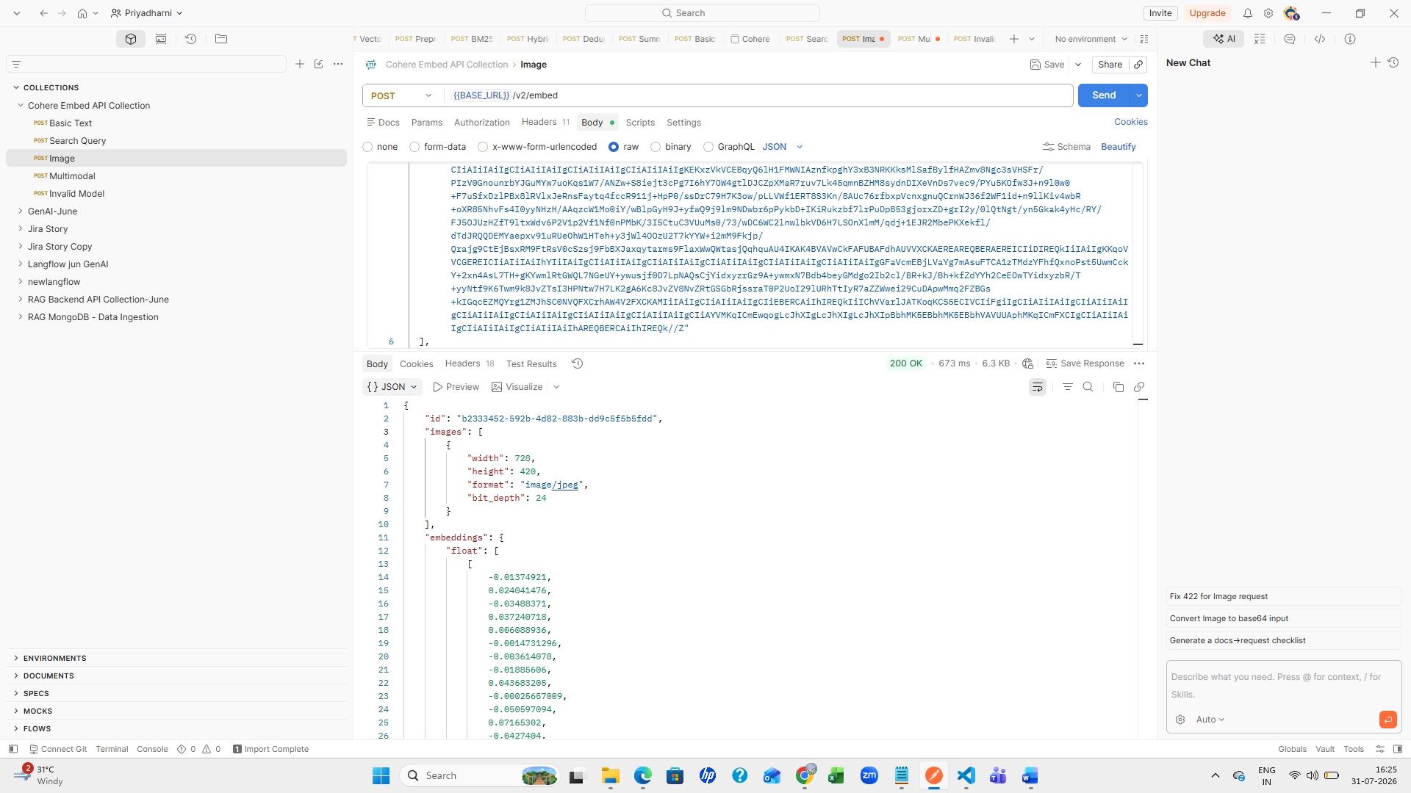
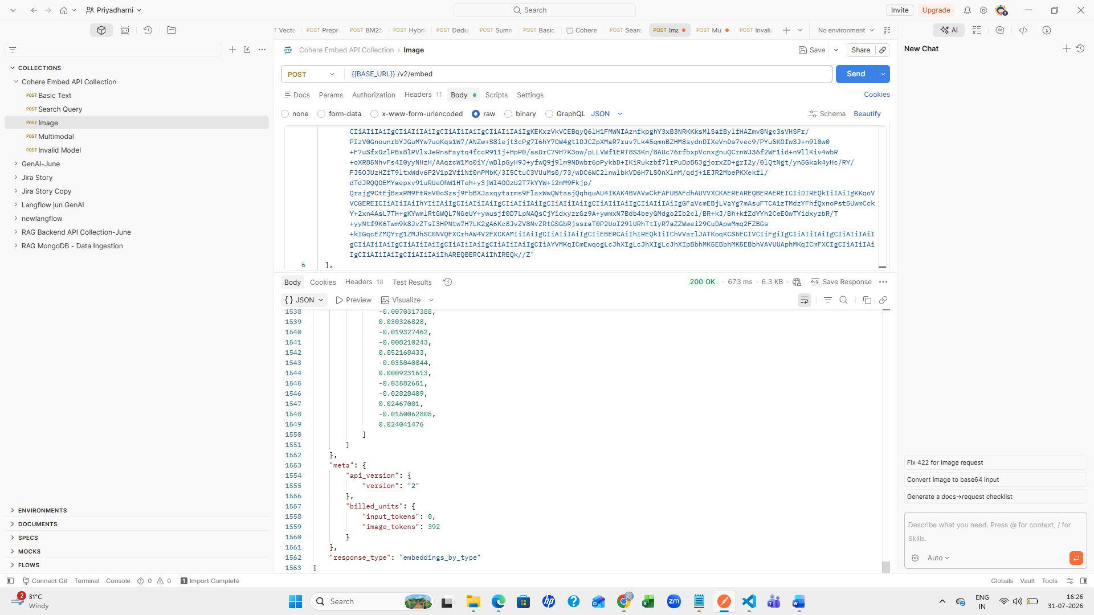
Multimodal
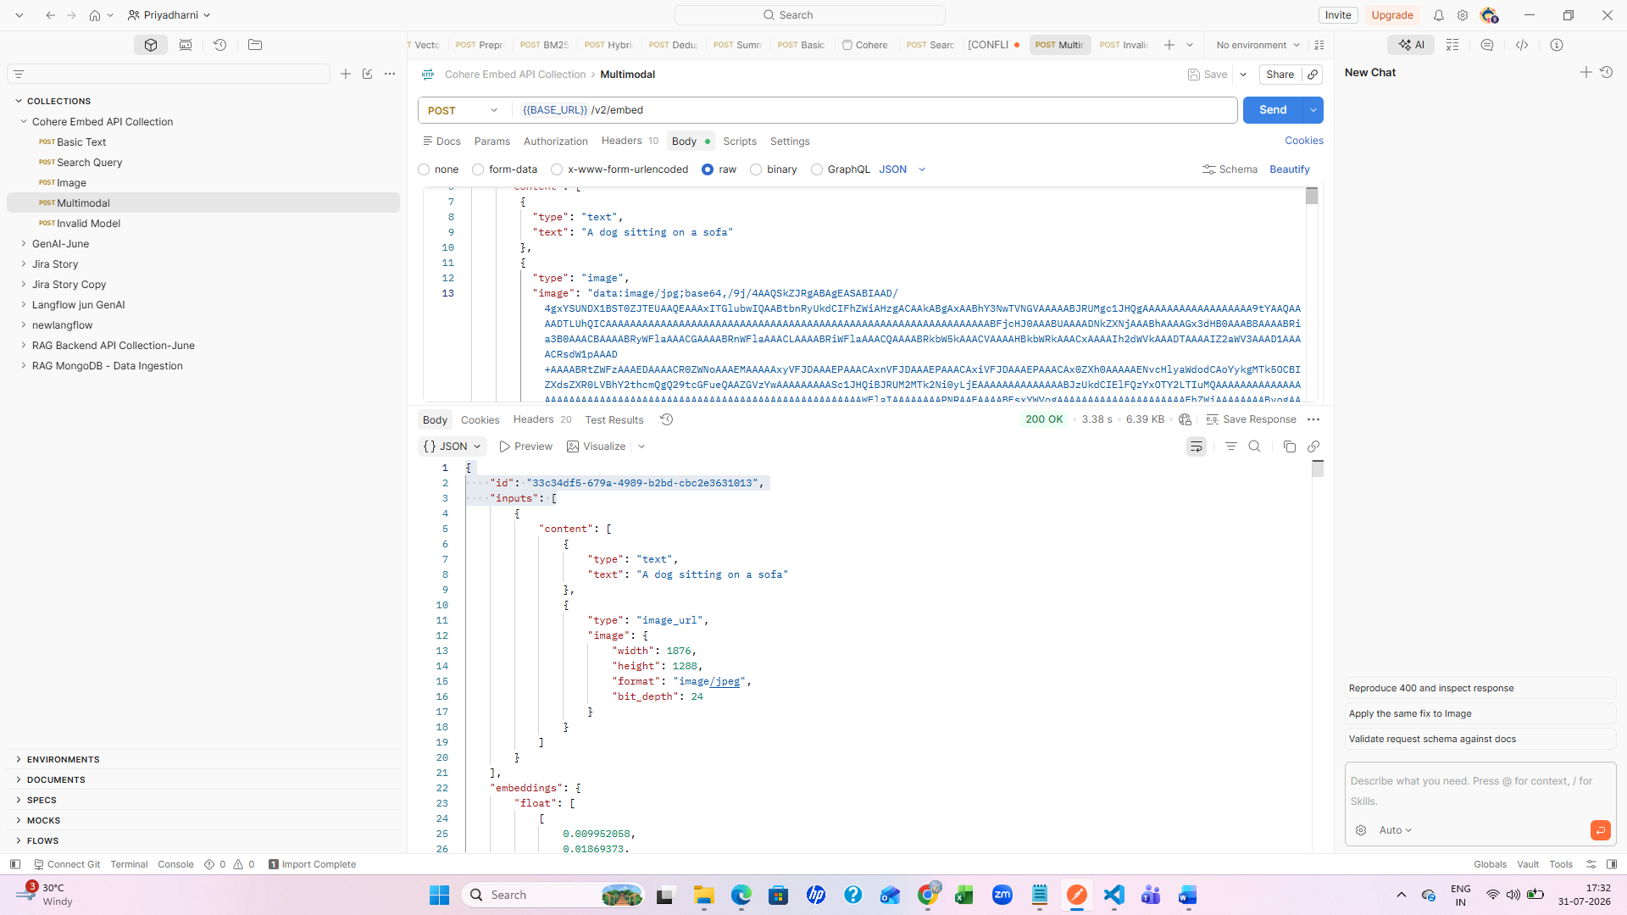
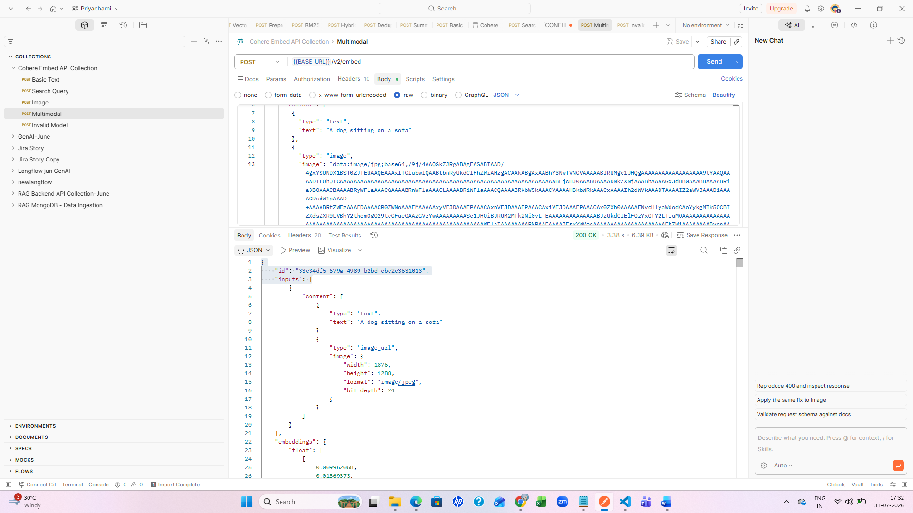
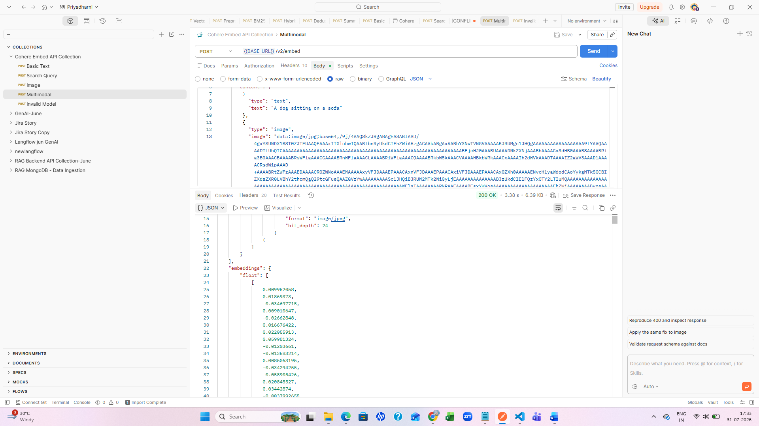
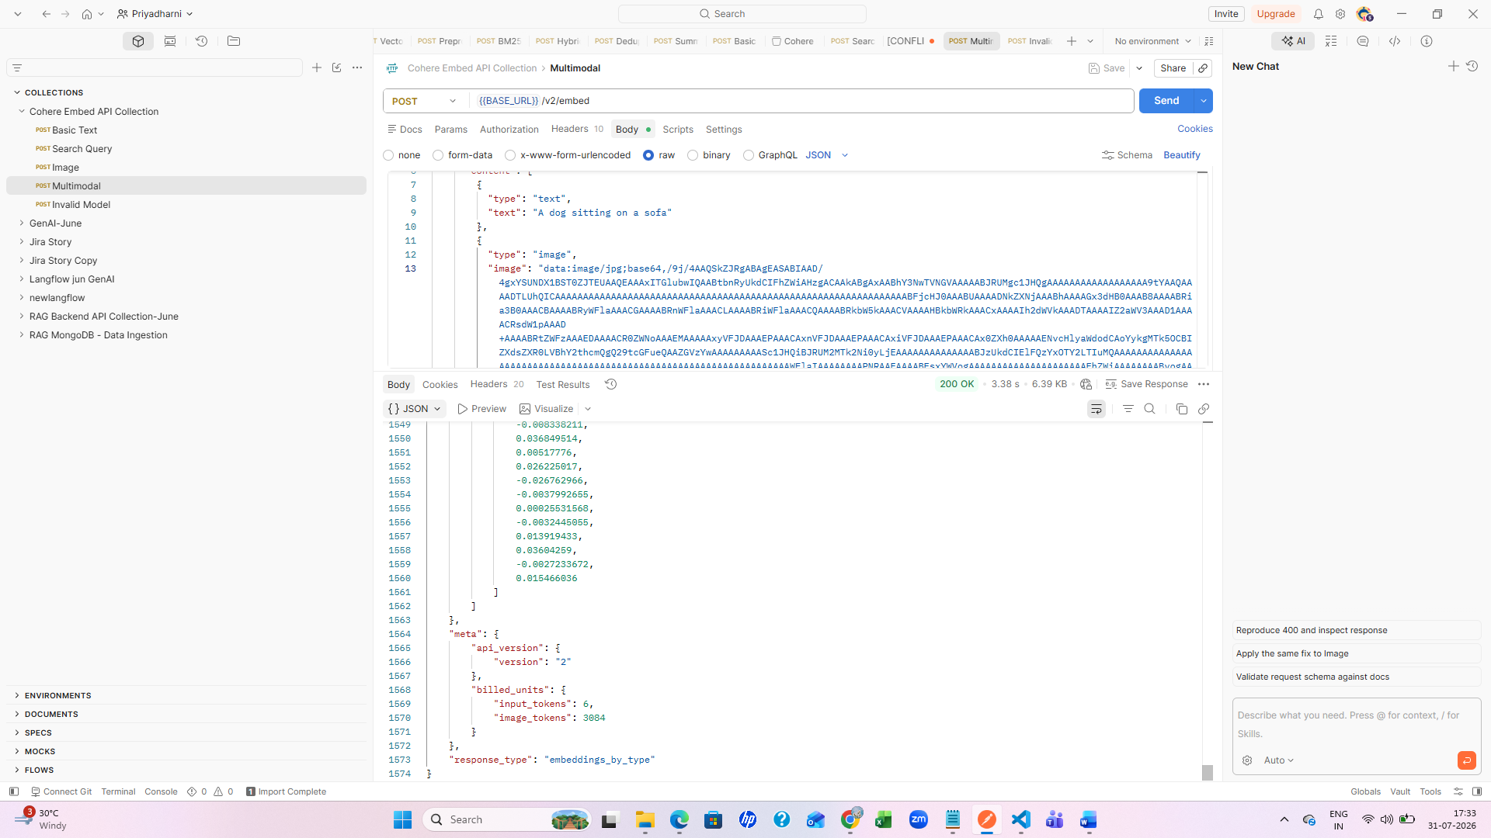

Invalid model
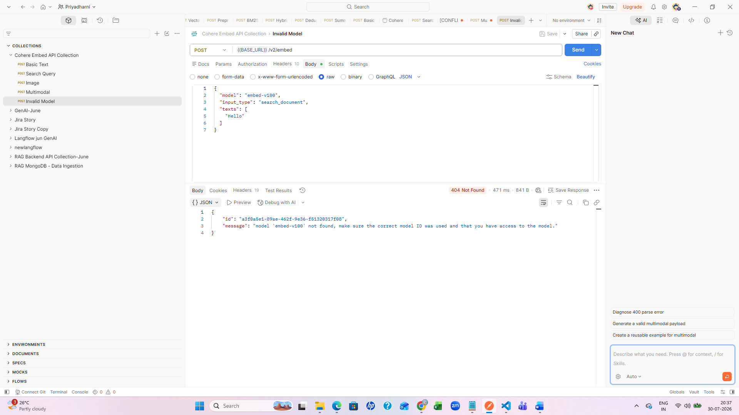
Sarvam API Postman collection
Text Processing
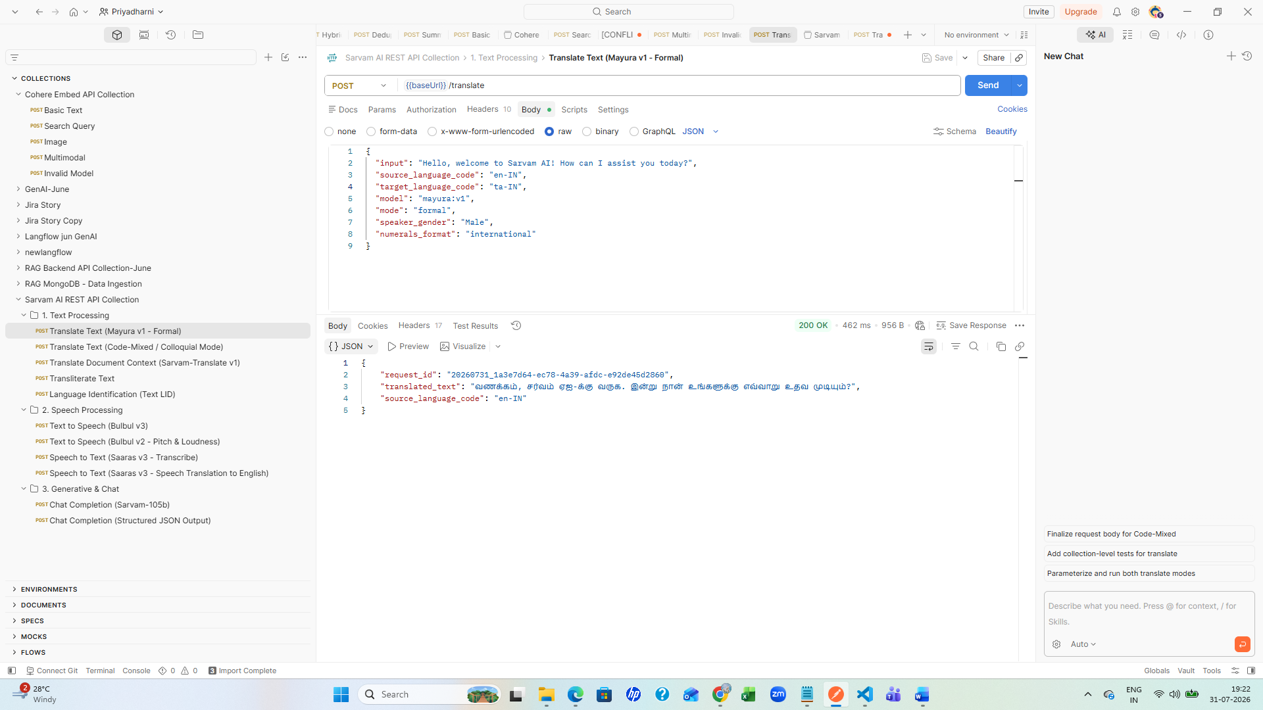
Translate text code mixed
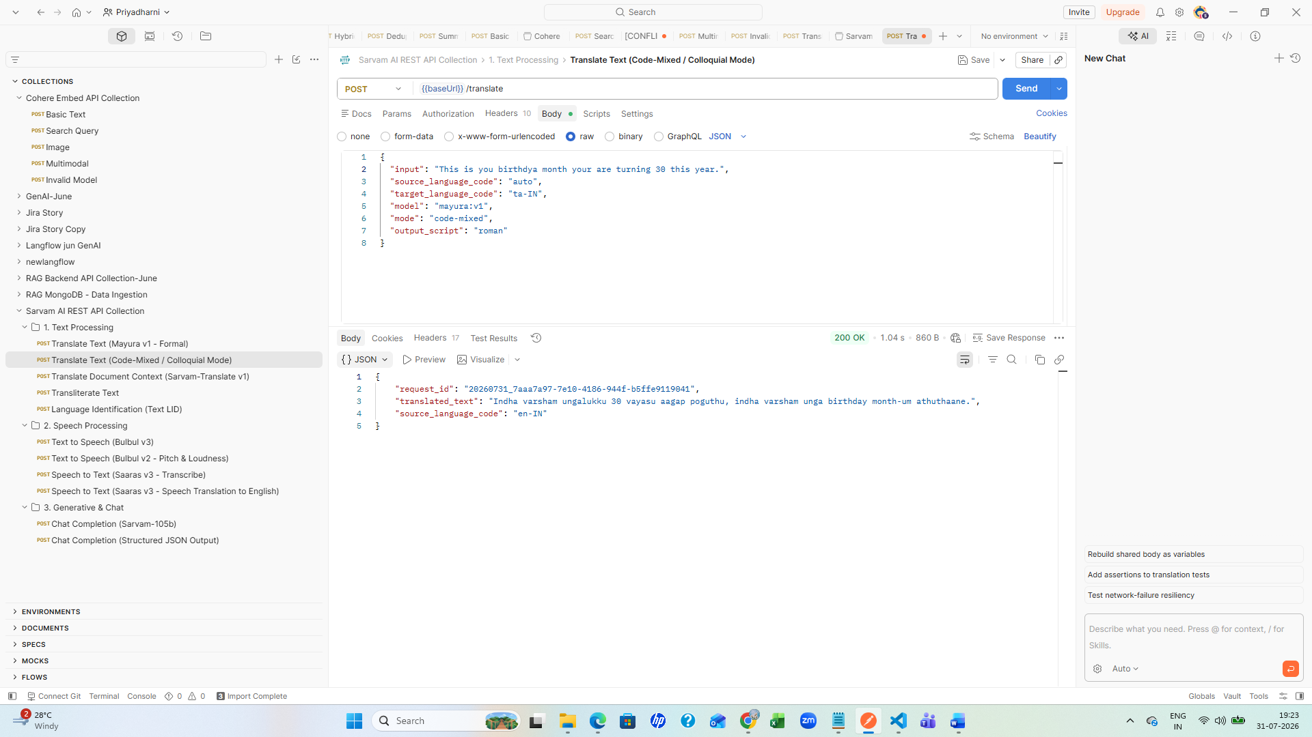
Trnaslate document context
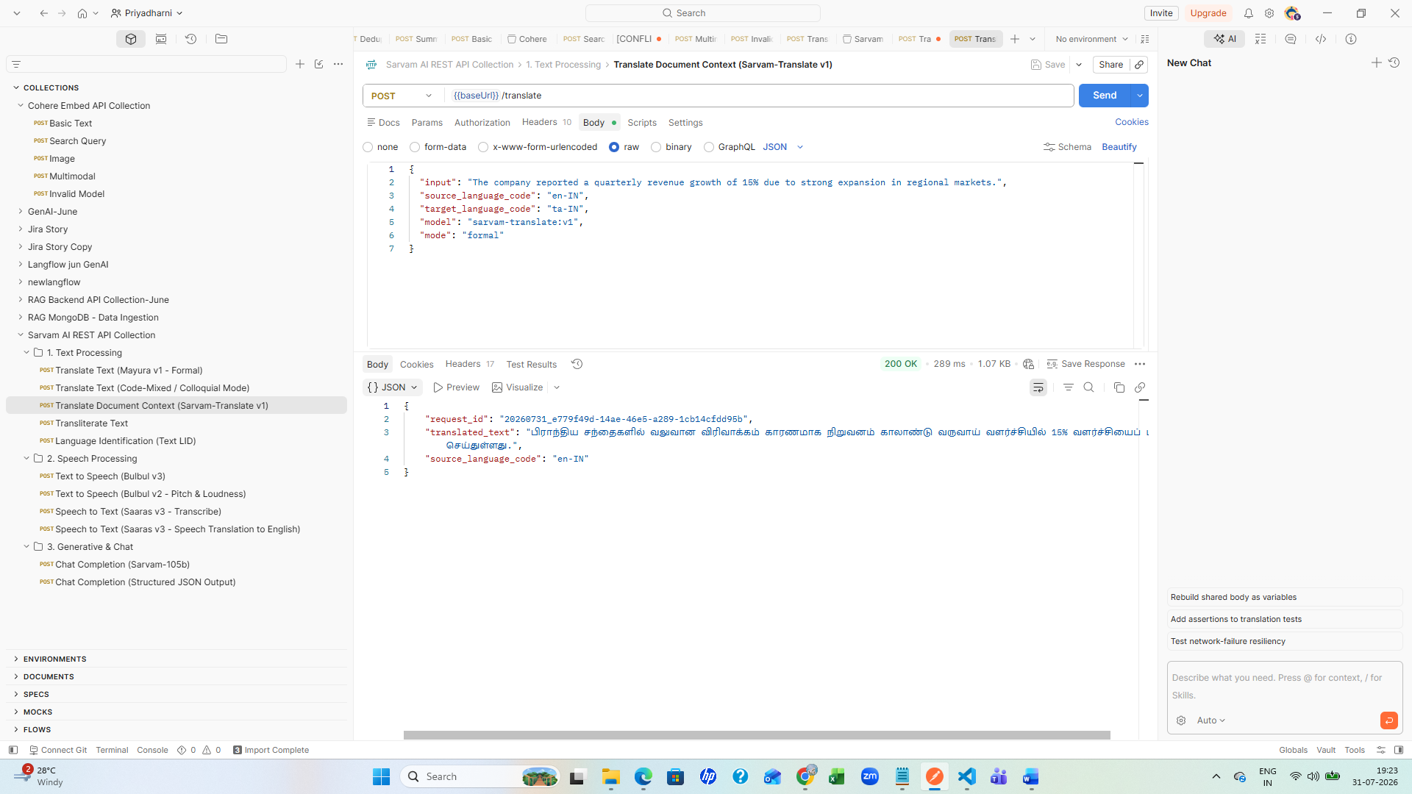
Transliterate
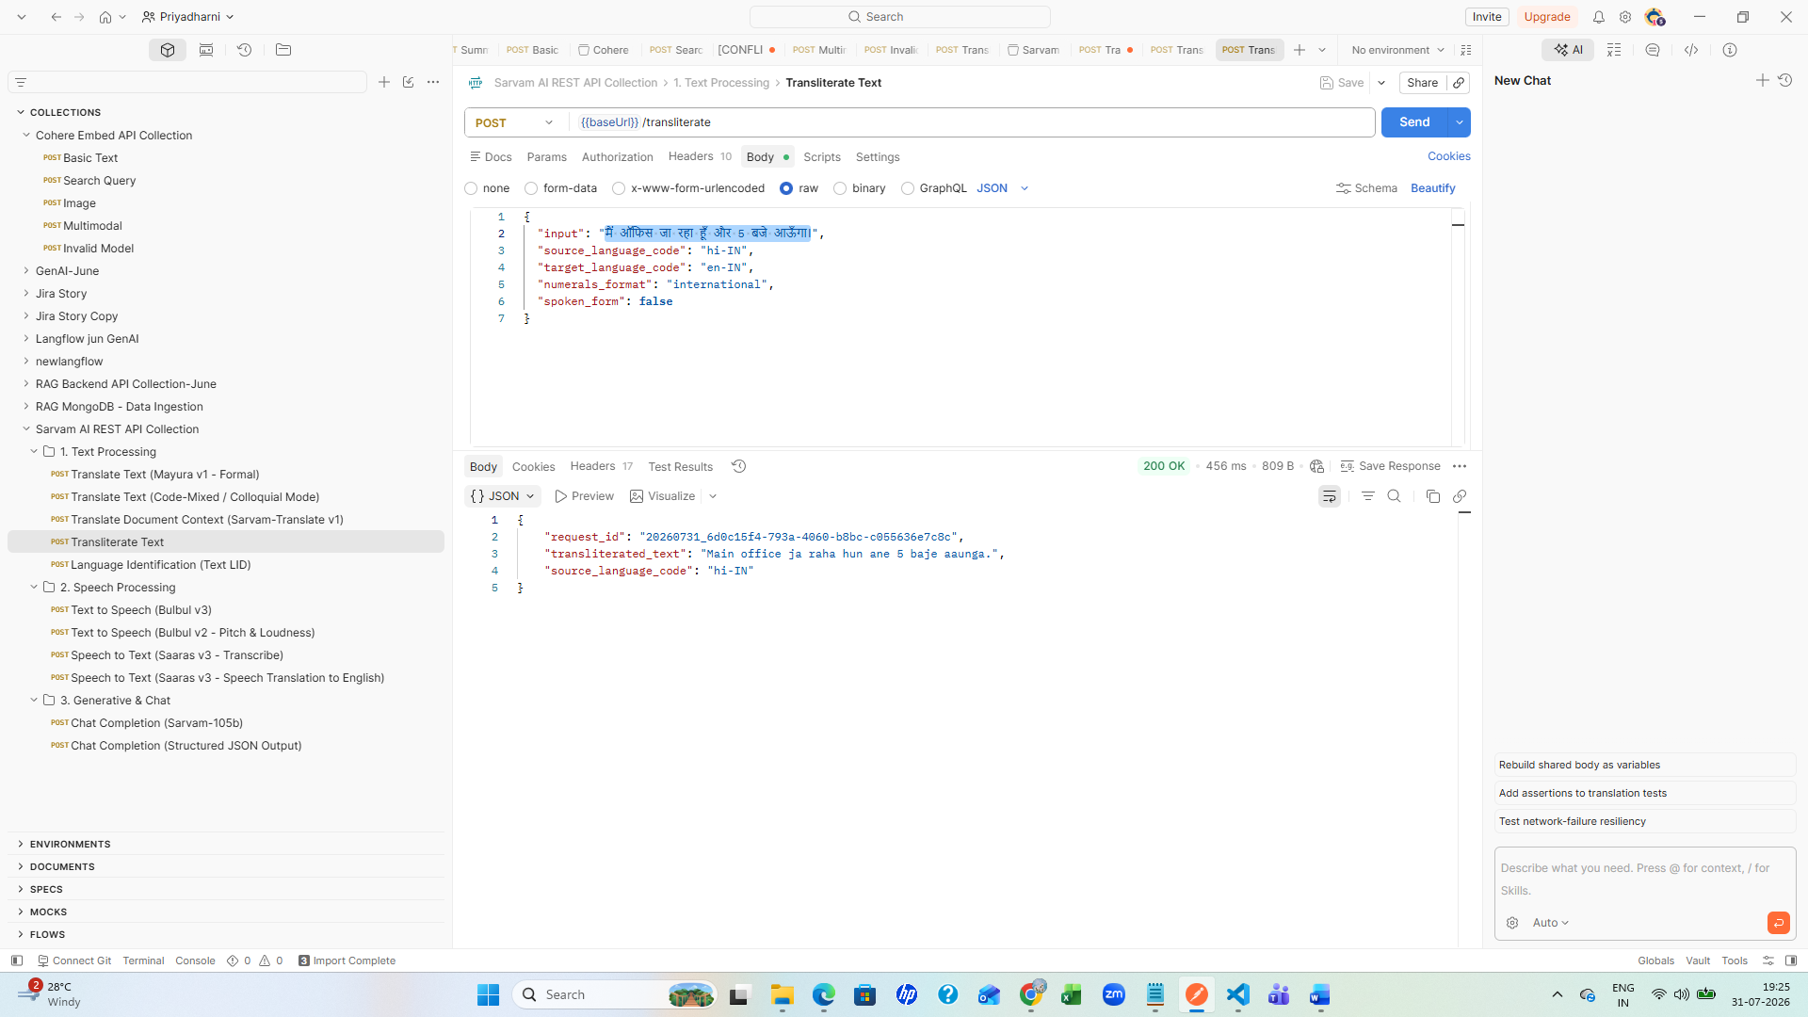
Speech processing
